Supporting information 1

Article title:
Consumer-mediated nutrient cycling in marine environments: a global meta-analysis

Journal:
Global Ecology and Biogeography

Authors:
Em G. Lim^{1§} and Isabelle M Côté¹

Affiliations
¹Biological Sciences, Simon Fraser University, Vancouver, British Columbia, CAN

§Corresponding author
Em G Lim: em_lim@sfu.ca; em.lim.phd@gmail.com
Department of Biological Sciences
Simon Fraser University
8888 University Drive
Burnaby, BC Canada V5A 1S6

S1: Full search string and restrictions for systematic review and meta-analysis

Web of Science:
TS= ((ammon* OR nitrog* OR phosph* OR nutrient) AND (excret* OR egest* OR mutual* OR symbio* OR subsid* OR consumer-mediat*) AND (coral* OR kelp* OR alga* OR macroalgae OR microalgae OR phytoplankton OR zooxanthell* OR primary prod* OR seagrass* OR sea grass* OR seaweed* OR mangrove*) AND (reef OR subtidal OR intertidal OR coast* OR marine OR benthic OR coral OR kelp) AND (grow* OR grew OR biomass OR abundance OR weight))
Limited to document types: (article or proceedings paper)
Limited to Web of science categories: (marine freshwater biology or engineering environmental or ecology or oceanography or zoology or environmental sciences or limnology or multidisciplinary sciences or biology or plant sciences or fisheries or biodiversity conservation)

ASFA:
noft((ammon* OR nitrog* OR phosph* OR nutrient) AND (excret* OR egest* OR mutual* OR symbio* OR subsid* OR consumer-mediat*) AND (coral* OR kelp* OR alga* OR macroalgae OR microalgae OR phytoplankton OR zooxanthell* OR primary prod* OR seagrass* OR sea grass* OR seaweed* OR mangrove*) AND (reef OR subtidal OR intertidal OR coast* OR marine OR benthic OR coral OR kelp) AND (grow* OR grew OR biomass OR abundance OR weight)) NOT mainsubject(freshwater OR bacteria OR aquaculture OR lakes OR rivers OR cyanobacteria OR biogeochemistry OR nitrogen fixation)
Limited to document types: (scholarly type, reports)
Excluded main subjects: (freshwater OR bacteria OR aquaculture OR lakes OR rivers OR cyanobacteria OR biogeochemistry OR nitrogen fixation)
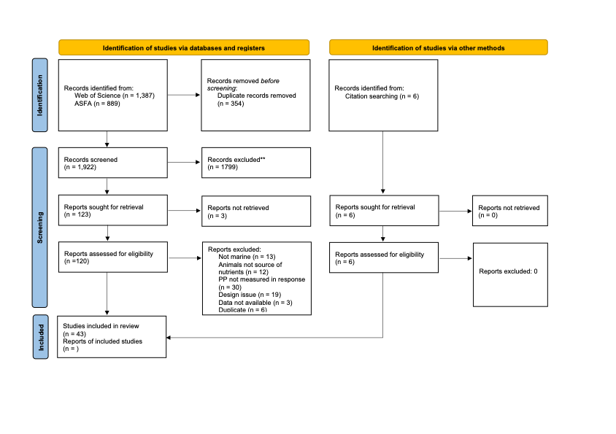
Figure S1. PRISMA flow diagram showing the number of studies at each stage of the systematic review process and reasons for exclusion. Each record had to meet the following criteria to be included: 1) the study was conducted in the marine environment, 2) treatment levels were established using manipulated or observed variation in animal-provisioned nutrients, but not using chemical fertilizer additions, 3) the response of primary producers to nutrient provisioning was measured quantitatively, 4) the effect of grazing was not confounded with the effect of nutrient provisioning, and 5) the study reported all necessary information required to calculate an effect size of animal-provisioned nutrients on primary productivity. Modified from Page MJ, McKenzie JE, Bossuyt PM, Boutron I, Hoffmann TC, Mulrow CD, et al. The PRISMA 2020 statement: an updated guideline for reporting systematic reviews. Systematic Reviews 2021;10:89. doi: 10.1186/s13643-021-01626-4

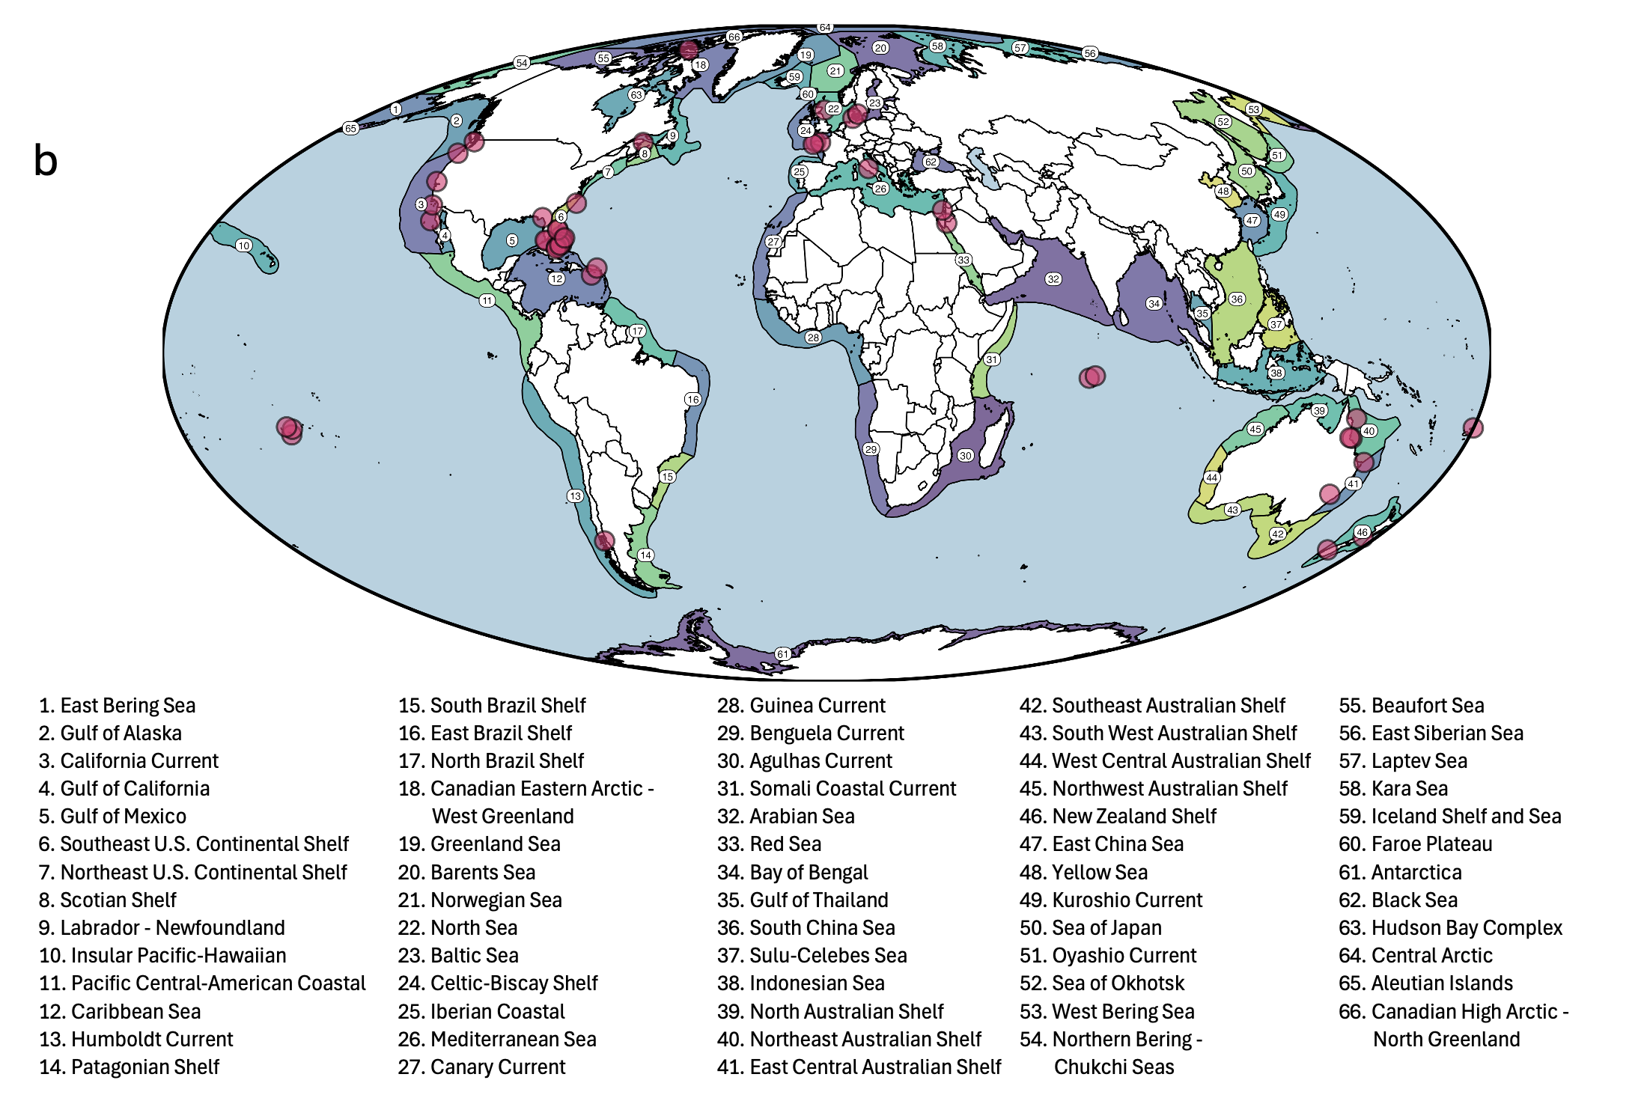

Figure S2. Geographical locations of studies distributed among the large marine ecosystems of the world.

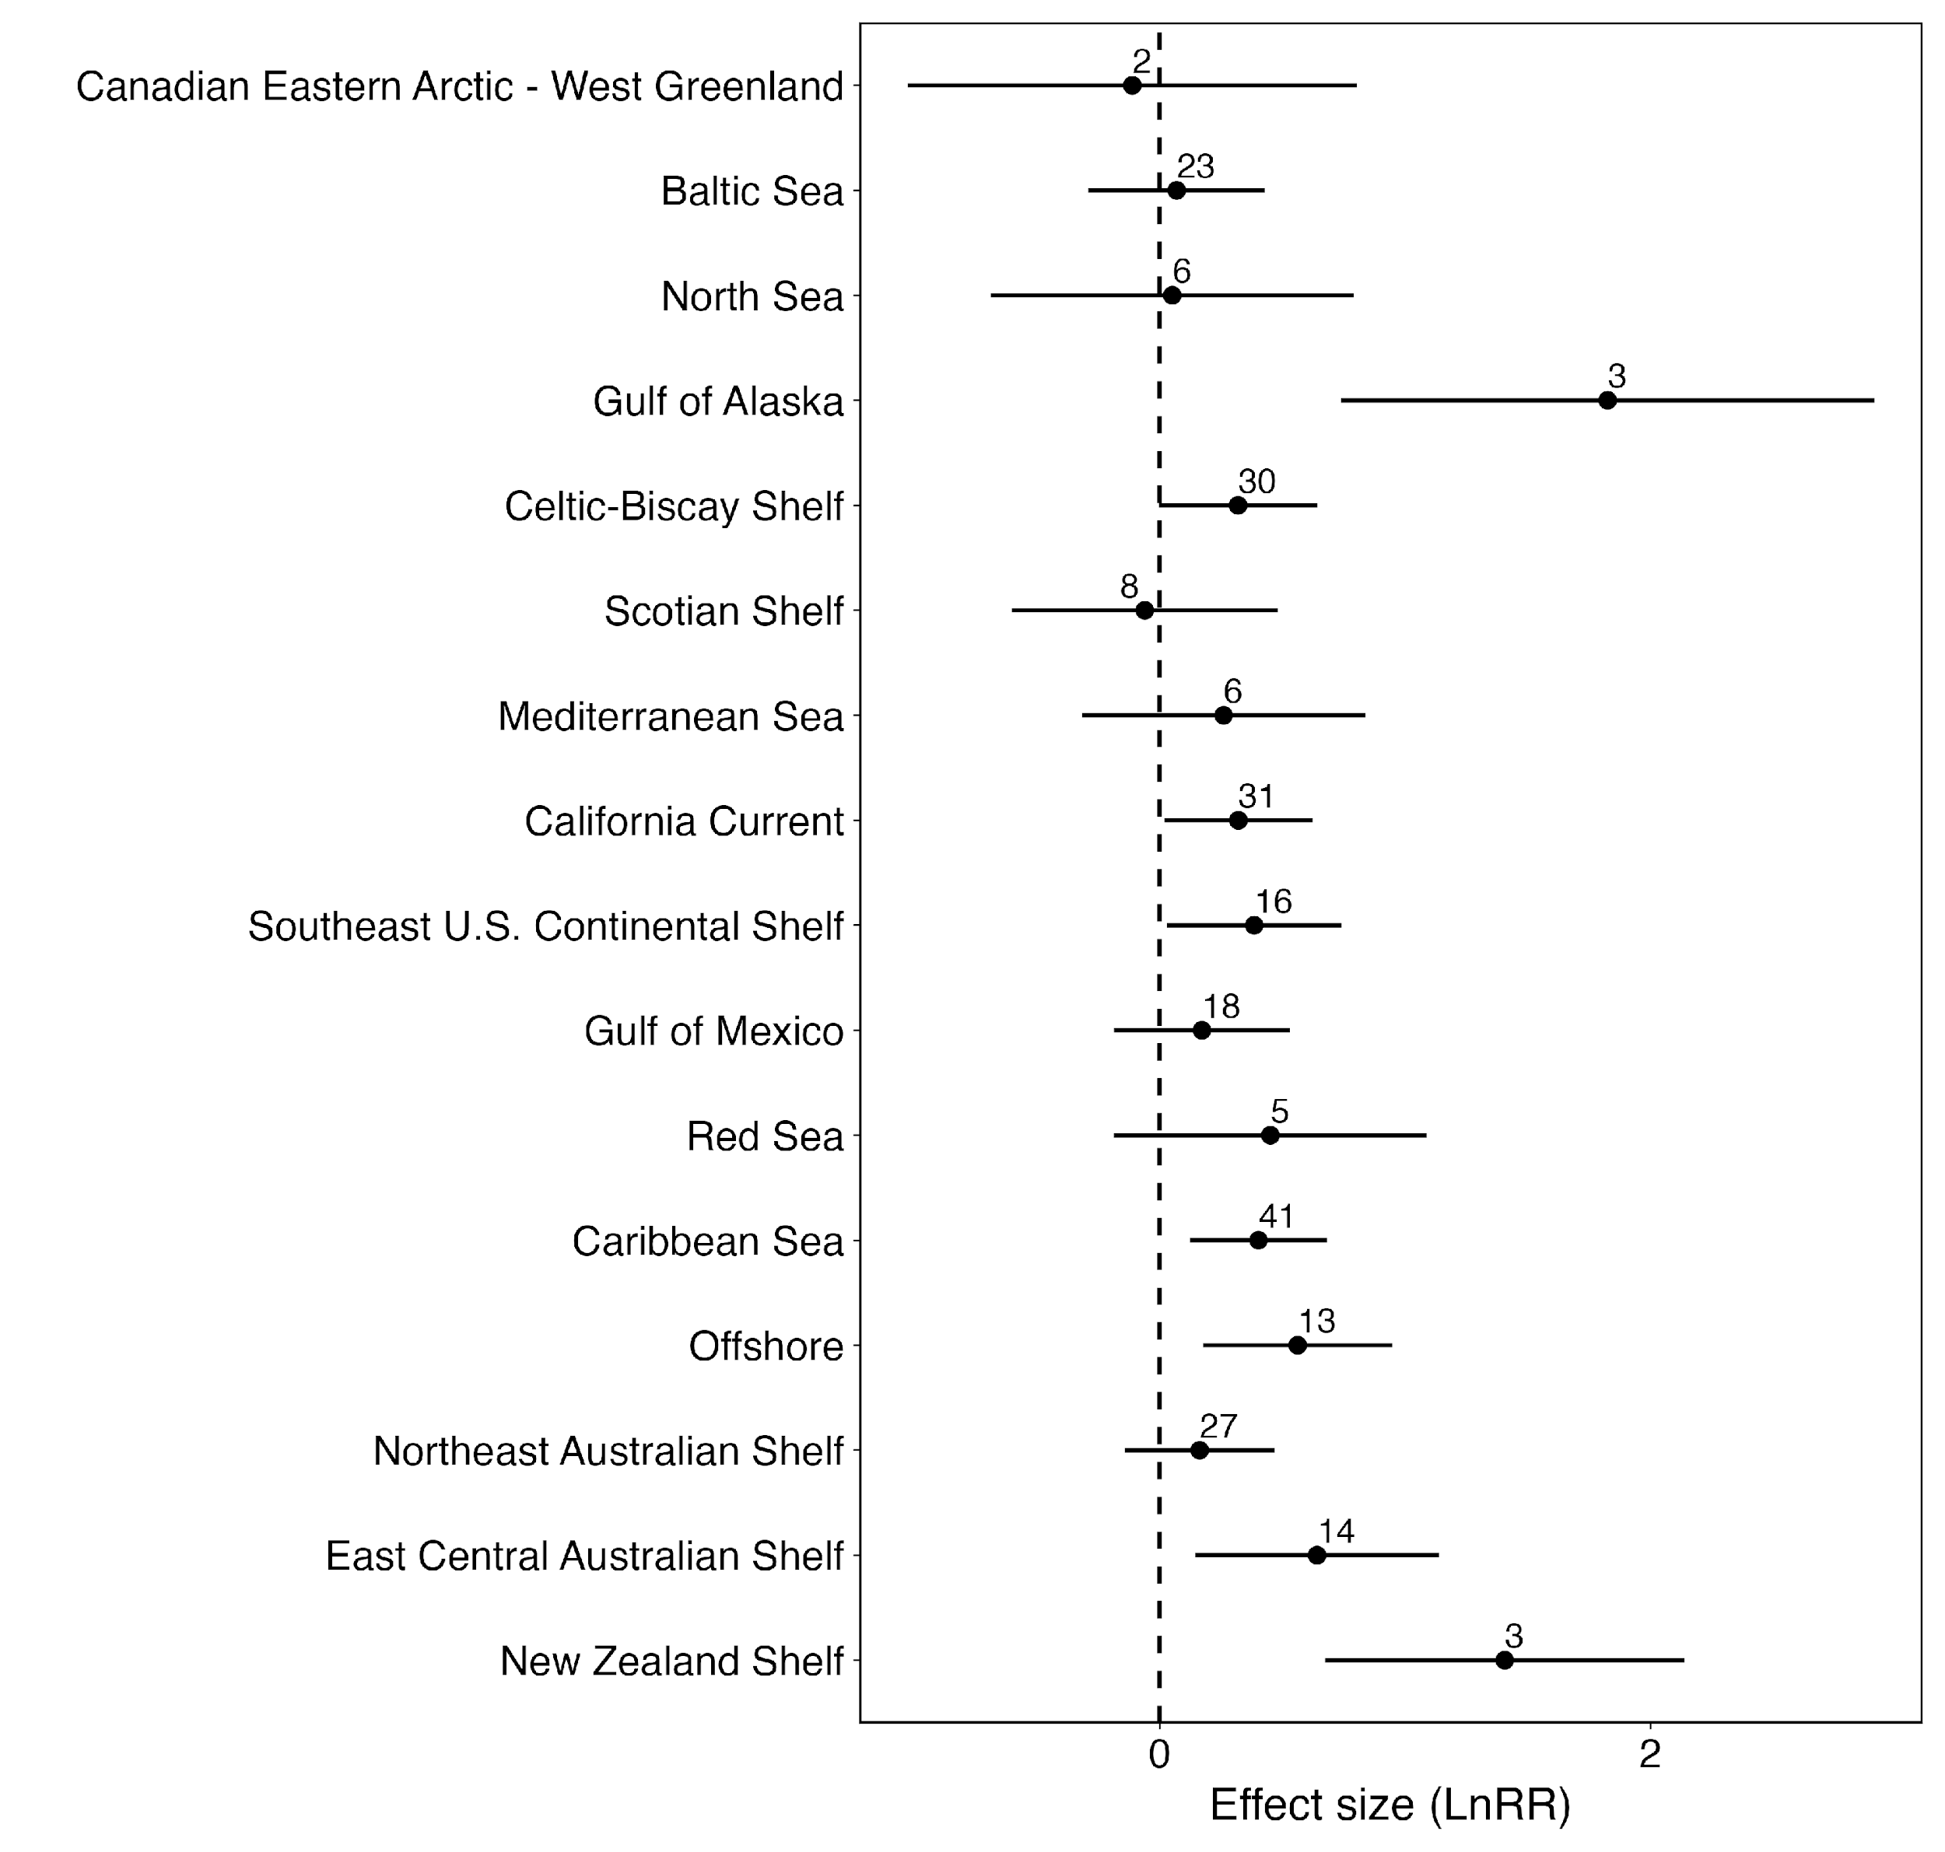
Figure S3. Results of the meta-regression model of the effect of nutrient provisioning by animals on primary producers across the large marine ecosystems. We constructed a model with LME as the only moderator to calculate mean effect sizes for each region. Estimated marginal means are shown as solid points surrounded by 95% confidence intervals with the number of effect sizes in each grouping shown above each point. “Offshore” refers to tropical offshore regions outside the 66 large marine ecosystems. While LMEs displayed variable responses to nutrient provisioning, there was no evidence of differences between LMEs.

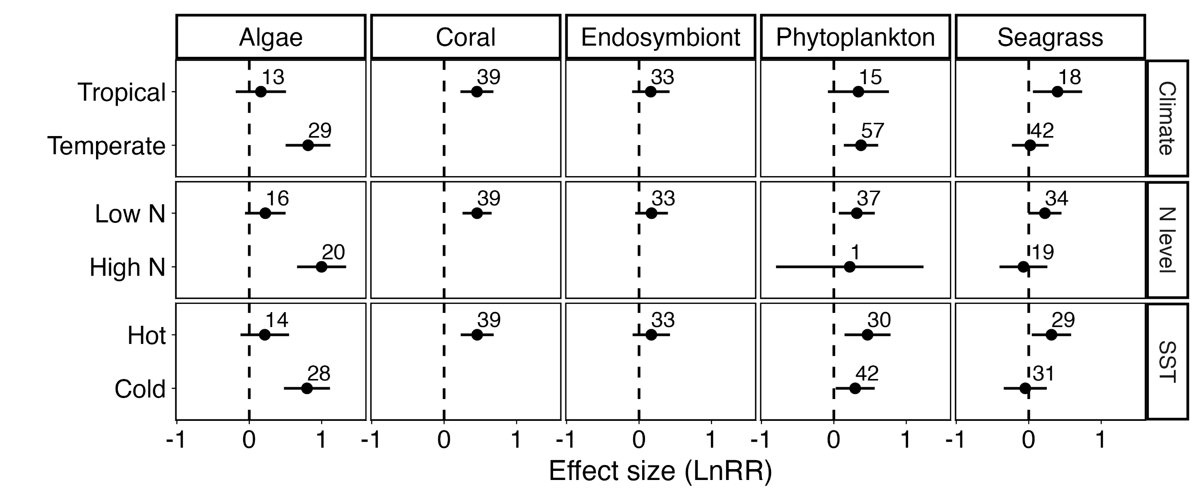
Figure S4. Estimated marginal means from the three simplified categorical meta-regression models: climate region (tropical vs temperate, top row), background N level (high vs low, middle row), and SST (high vs low, bottom row). Each filled dot indicates the estimated overall effect for that treatment level, with lines showing 95% confidence intervals and number of effect sizes in each group (n) is shown. Although there is no single definition of the extent of the tropics (Feeley & Stroud, 2018), we chose 30° absolute latitude as the cut-off because it encompassed multiple definitions and seemed to best align with authors’ designation of their own sites. We classified studies as having high or low background N availability based on the authors’ characterizations of their study site when provided. We chose 20°C as the cut off between high and low SST. For each of these three categorical moderators, we also included primary producer group as well as a 2-way interaction with the categorical predictor. The models considering latitude, background nutrients, and temperature as categorical variables uncovered similar trends as the models with continuous variables (Tables S4–S9). Algae responded almost 2x more strongly to nutrient provisioning in temperate, high nitrogen, cool waters (p < 0.01 for all three pairwise comparisons). The response of seagrass to CNC was weaker and opposite to that of algae: ~ 1.5 more strongly to CNC in tropical (p = 0.08), low-nitrogen (p = 0.15), warmer waters (p = 0.08). Phytoplankton did not differ in their response between regions (p > 0.42 for all pairwise comparisons), and there were no coral or endosymbiont studies in temperate, high-N, cool regions, so comparisons were not possible for these groups.

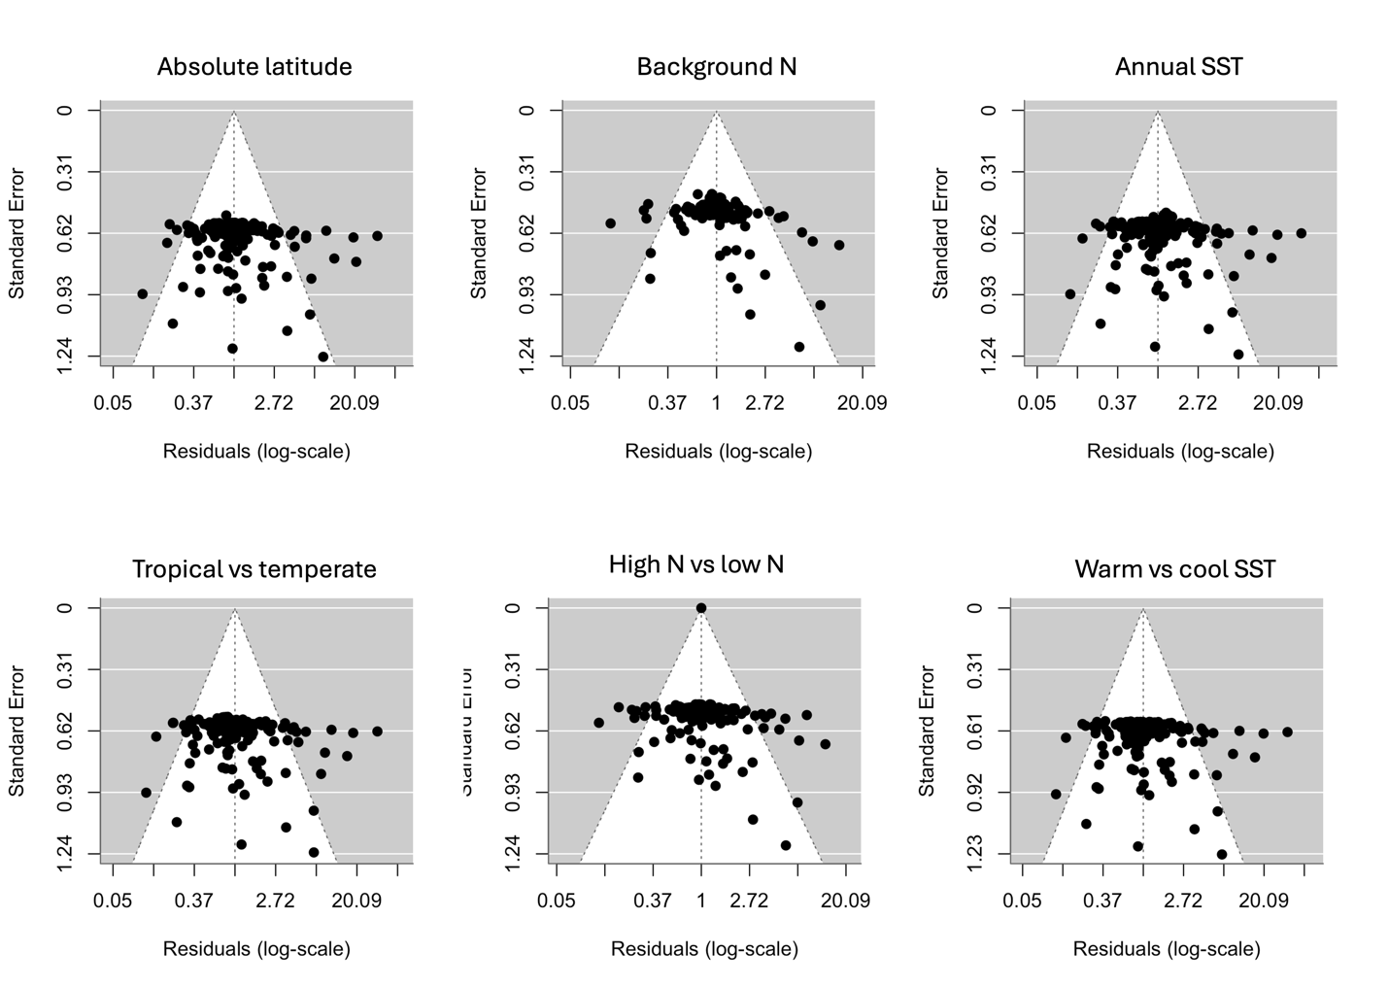
Figure S5. Funnel plots for the mixed-effects multilevel meta-regression model including (a) absolute latitude, (b) background nitrogen, (c) annual sea surface temperature, (d) tropical vs temperate climate region, (e) low vs high background N, and (f) high vs low sea surface temperature. Residual value is plotted along the x-axis on a log scale as we calculated our effect sizes as log-transformed ratios of means. We see an unusual pattern where many studies have low standard error but a wide range of residuals. However, the points are fairly well distributed around the log-transformed residual value of 0, reflecting limited publication bias in our results.

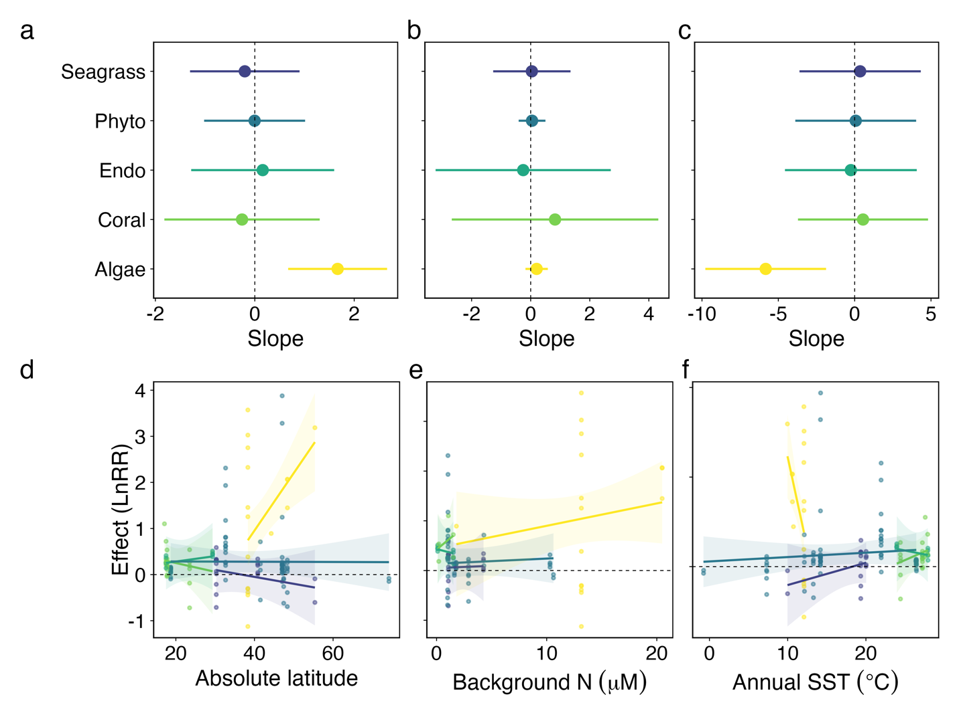
Figure S6. Results of the meta-regression models including (a, d) absolute latitude, (b, e) background N, (d, f) annual sea surface temperature as continuous moderators with the level of N provisioning (i.e. supply rate) included as a covariate in each model. Effect of each moderator on the response of seagrass (purple), phytoplankton (blue), endosymbionts (teal), coral (green), and algae (yellow) to nutrient provisioning by animals shown as (a – d) estimated slopes (filled dots) with 95% confidence intervals (surrounding lines) and (e – f) model-generated predictions across moderator ranges for each producer group, with raw effect sizes plotted as filled dots.

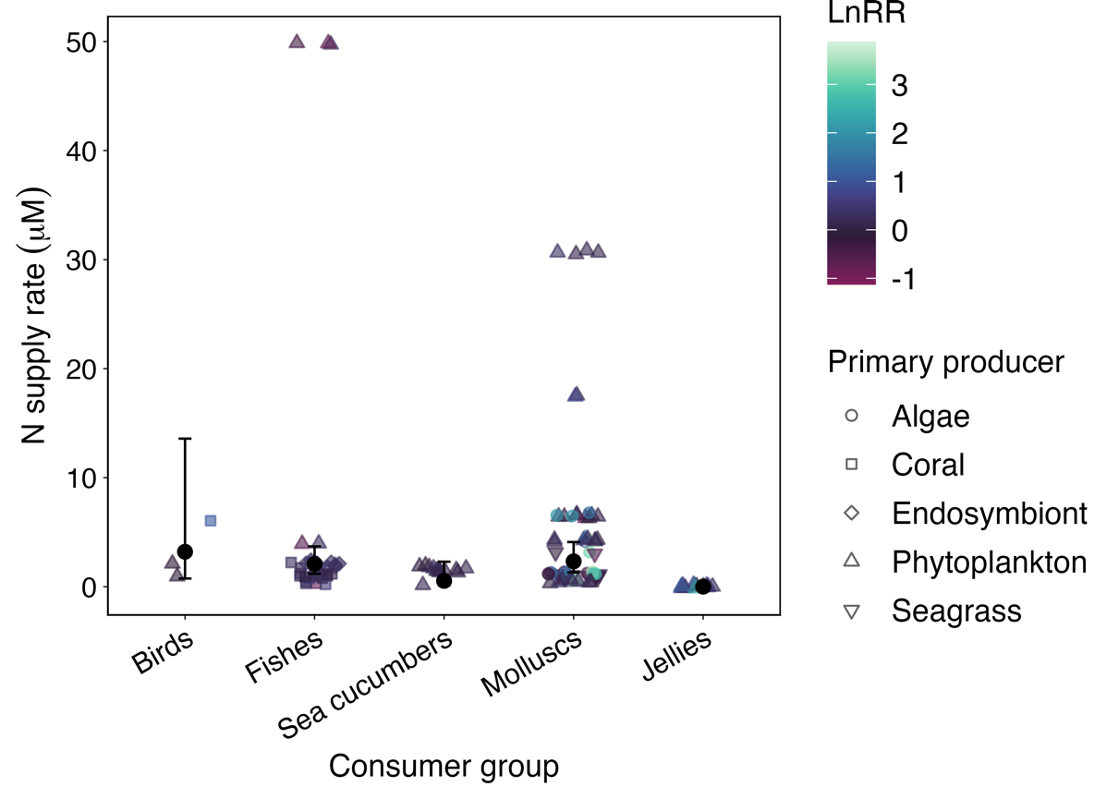
Figure S7. Mean level of N provisioning (i.e. supply rate) to primary producers from each provisioning consumer taxa. Small dots are raw data points, colour indicates log-transformed response ratio (effect size). Large dots and whiskers indicate mean ± SE.

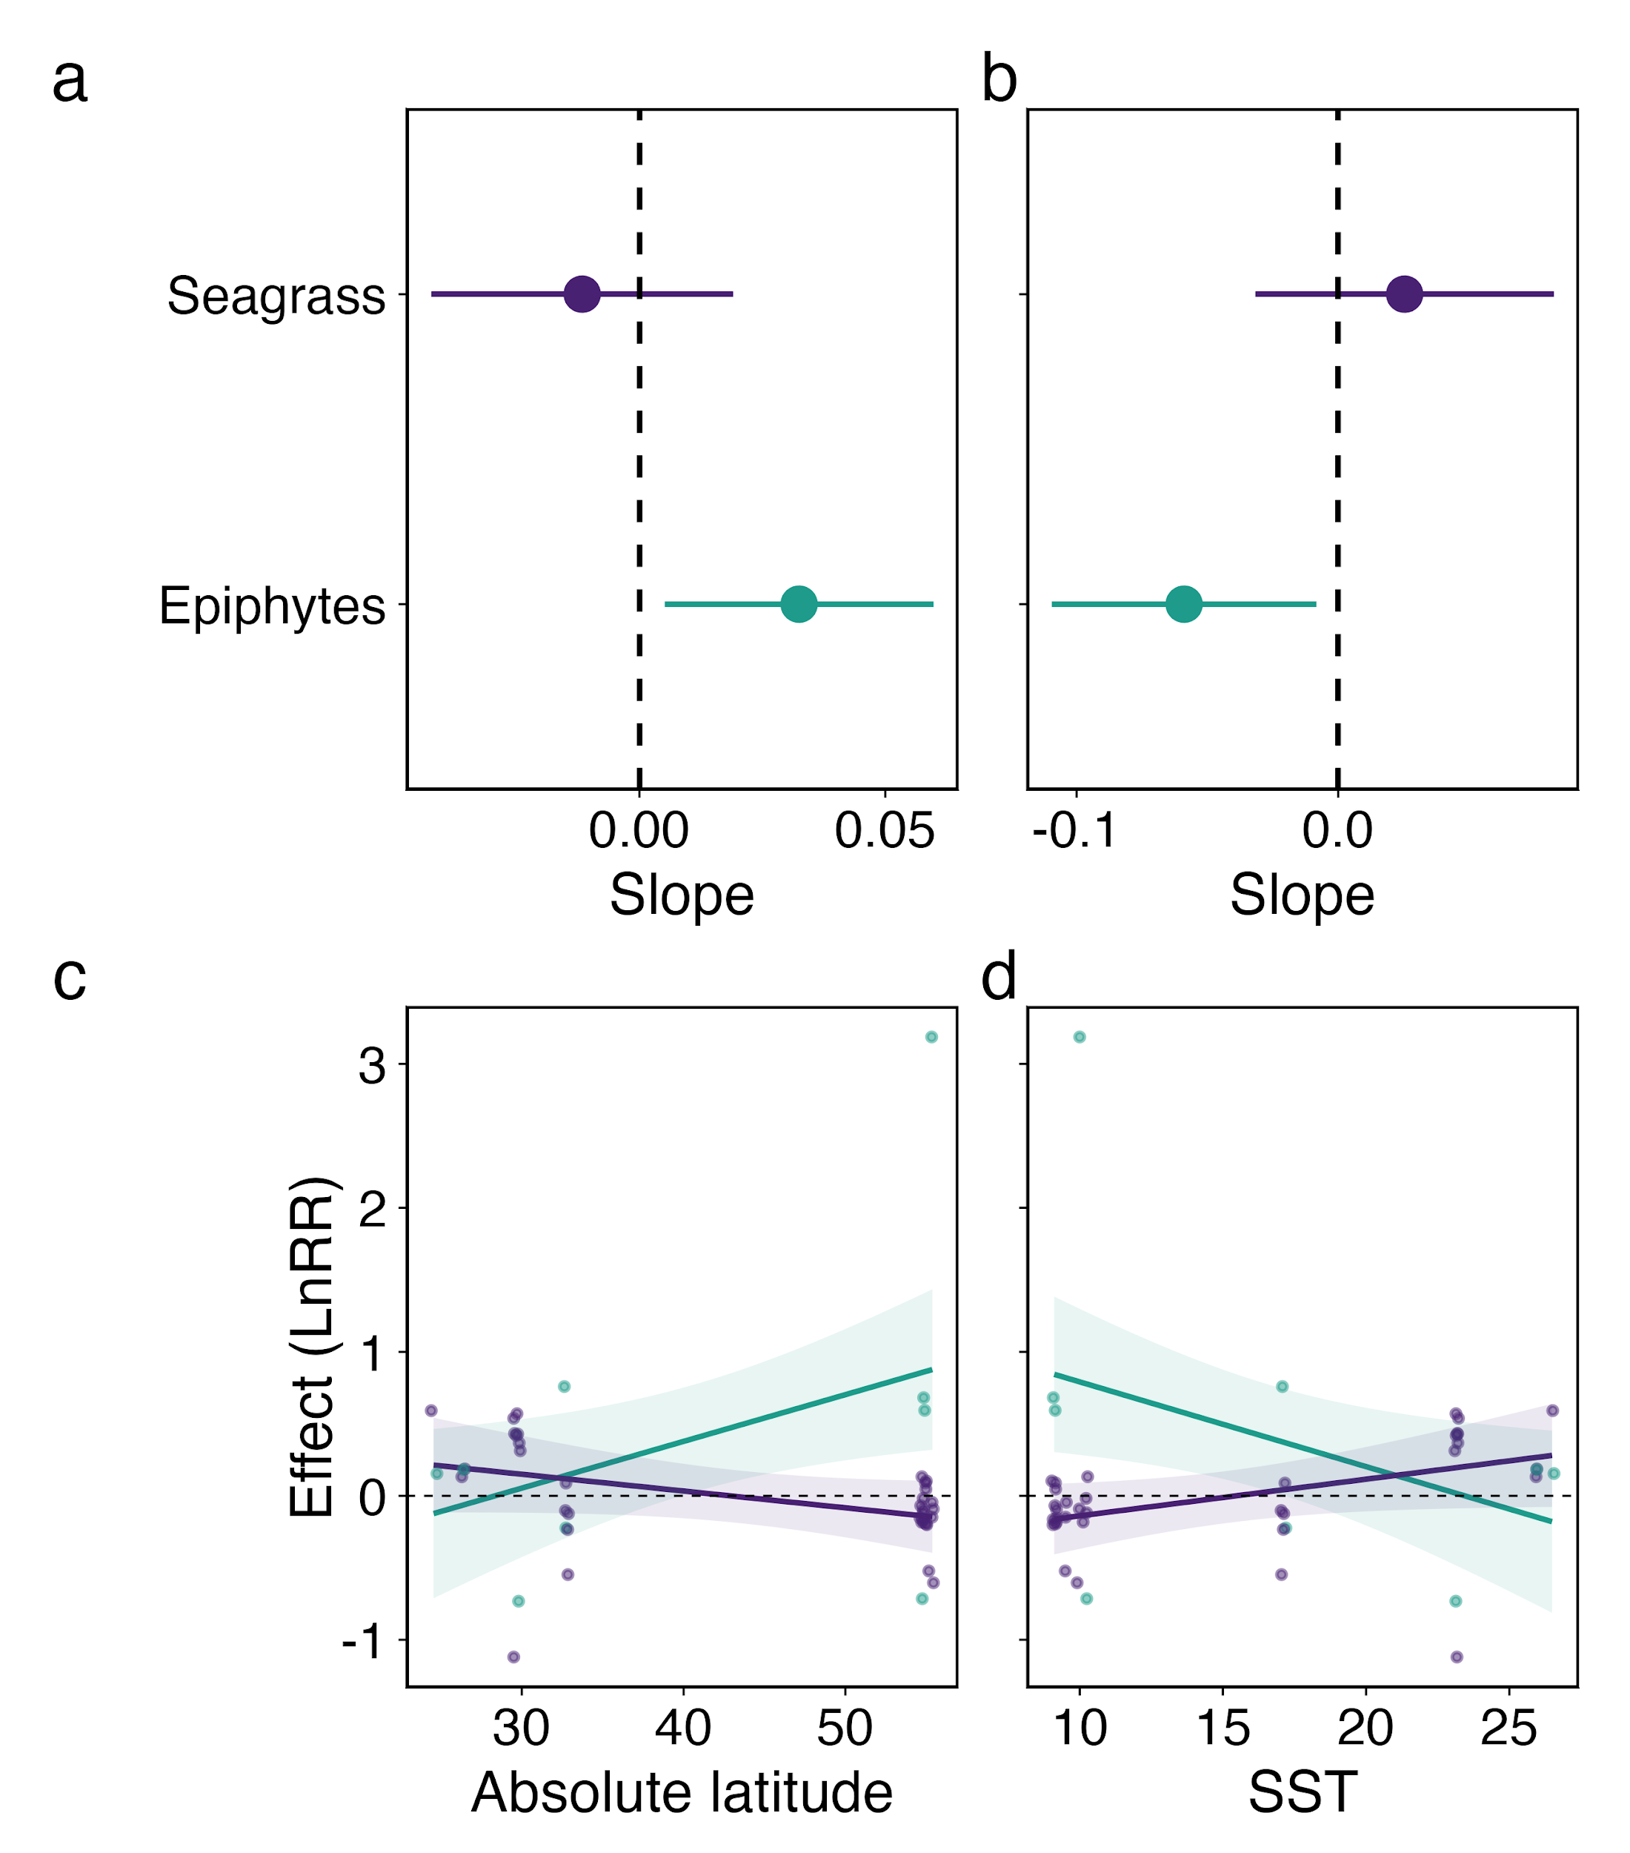
Figure S8. Results of the meta-regression models of the effect of nutrient provisioning by animals on seagrass and epiphytes across (a, c) absolute latitude, and (b, d) annual sea surface temperature. Effect of each moderator on the response of seagrass (purple), and epiphytes (teal) to nutrient provisioning by animals shown as (a, b) estimated slopes (filled dots) with 95% confidence intervals (surrounding lines) and (c, d) model-generated predictions across moderator ranges for each producer group, with raw effect sizes plotted as filled dots. Only studies that measured simultaneously the effects of nutrient additions on seagrass and epiphytes are included.

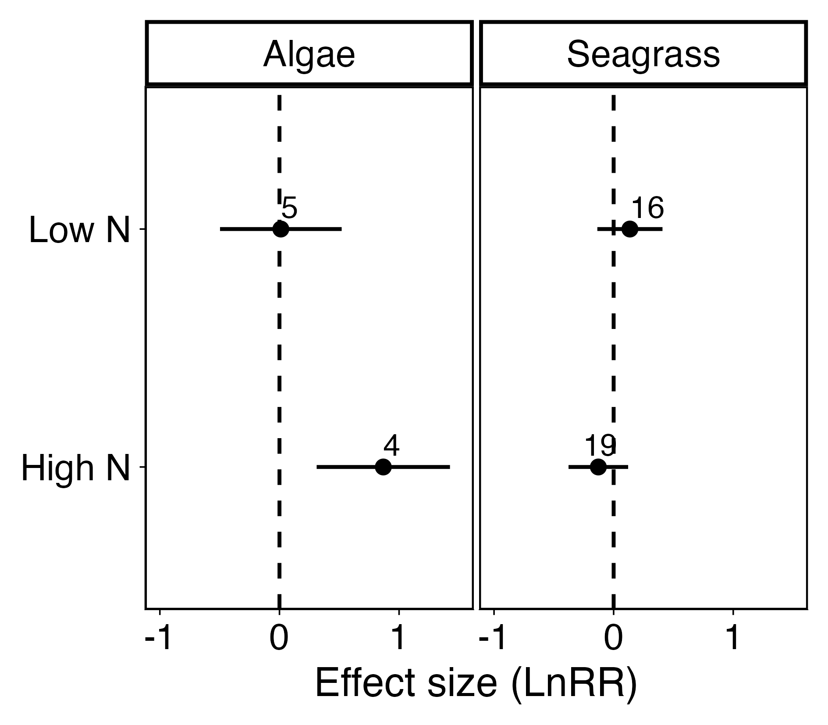
Figure S9. Estimated marginal means from the meta-regression model of the effect of nutrient provisioning by animals on seagrass and epiphytes in high and low nitrogen regions. Filled dot indicate the estimated overall effect surrounded by 95% confidence intervals and number of effect sizes in each group (n) is shown. Only studies that measured simultaneously the effects of nutrient additions on seagrass and epiphytes are included. Not enough studies on seagrass and epiphytes reported background N levels to consider this variable as a continuous predictor, so we classified studies as having high or low background N availability based on the authors’ characterization of their study site and conducted a categorical comparison.

Tables: For the primary producer groups, we abbreviated phytoplankton (Phyto) and endosymbionts (Endo). NA = No data to perform this comparison.

Table S1. Estimated marginal means from the meta-regression model describing the responses of primary producers to consumer-mediated nutrient provisioning when the authors measured the response of producers only at the end of the experiment (end point), as growth rates over time (growth rate), or as an instantaneous performance metric (instantaneous). We found no difference in effect sizes between these three types of measurement using pairwise comparisons (Table S2).
 | estimate | SE | t-value | df | p-value
End point | 0.30 | 0.10 | 3.02 | 243 | 0.003
Growth rate | 0.39 | 0.08 | 4.6 | 243 | < 0.001
Instantaneous | 0.31 | 0.08 | 3.67 | 243 | < 0.001

Table S2. Pairwise comparisons of the effect of consumer-mediated nutrient provisioning on productivity between responses for each primary producer group. These comparisons were generated from the model shown in Table S1.
contrast | estimate | SE | df | t-ratio | p-value
End point - Growth | -0.08 | 0.12 | 243 | -0.70 | 0.76
End point - Inst | -0.01 | 0.12 | 243 | -0.08 | 1.00
Growth - Inst | 0.07 | 0.11 | 243 | 0.66 | 0.78

Table S3. Results of the three-level mixed-effects meta-regression model of the responses of primary producers to consumer-mediated nutrient provisioning with measured temperature as a continuous moderator (not sea surface temperature). For the experimental design levels, the estimate and p-value represent a comparison to the “control” level, i.e. unstocked field experiment. For the primary producer groups, the “control” level is algae. We found a negative effect of temperature on the response of algae to consumer-mediated nutrient cycling, but a positive effect for seagrass. We found no trend for corals, endosymbionts, or phytoplankton.
 | estimate | SE | t-value | df | p-value
Intercept | 0.55 | 0.19 | 2.87 | 158 | 0.005
Temperature | -0.04 | 0.04 | -1.11 | 158 | 0.27
Coral | 0.37 | 0.65 | 0.56 | 158 | 0.57
Endo | -0.24 | 0.57 | -0.42 | 158 | 0.68
Phyto | -0.12 | 0.23 | -0.51 | 158 | 0.61
Seagrass | -0.51 | 0.25 | -2.08 | 158 | 0.04
Temperature: Coral | -0.03 | 0.12 | -0.2 | 158 | 0.84
Temperature: Endo | 0.02 | 0.12 | 0.13 | 158 | 0.9
Temperature: Phyto | 0.04 | 0.04 | 1.07 | 158 | 0.28
Temperature: Seagrass | 0.06 | 0.05 | 1.35 | 158 | 0.18

Table S4. Results of the three-level mixed-effects meta-regression model comparing the response of producers to consumer-mediated nutrient provisioning between tropical (< 30° absolute latitude) and temperate (> 30°) regions. For the primary producer groups, the “control” level is algae, and “temperate” is the control level for climate region.
 | estimate | SE | t-value | df | p-value
Intercept | 0.81 | 0.16 | 5.17 | 238 | < 0.001
Tropical | -0.65 | 0.24 | -2.76 | 238 | 0.01
Coral | 0.29 | 0.20 | 1.47 | 238 | 0.14
Endo | 0.002 | 0.20 | 0.01 | 238 | 0.99
Phyto | -0.44 | 0.20 | -2.21 | 238 | 0.03
Seagrass | -0.79 | 0.19 | -4.25 | 238 | < 0.001
Tropical: Phyto | 0.62 | 0.34 | 1.82 | 238 | 0.07
Tropical: Seagrass | 1.03 | 0.30 | 3.42 | 238 | < 0.001

Table S5. Pairwise comparisons of the effect of consumer-mediated nutrient provisioning on productivity between climate regions for each primary producer group. These comparisons were generated from the model shown in Table S4.
contrast | pp | estimate | SE | df | t-ratio | p-value
Temperate - Tropical | Algae | 0.65 | 0.24 | 238 | 2.76 | 0.01
Temperate - Tropical | Coral | NA | NA | NA | NA | NA
Temperate - Tropical | Endo | NA | NA | NA | NA | NA
Temperate - Tropical | Phyto | 0.04 | 0.25 | 238 | 0.15 | 0.88
Temperate - Tropical | Seagrass | -0.38 | 0.22 | 238 | -1.75 | 0.08

Table S6. Results of the three-level mixed-effects meta-regression model comparing the response of producers to consumer-mediated nutrient provisioning between cold (< 20°C) and hot (> 20°C) annual sea surface temperature (SST) regions. For the primary producer groups, the “control” level is algae, and “Cold” is the control level for SST.
 | estimate | SE | t-value | df | p-value
Intercept | 0.80 | 0.16 | 4.94 | 238 | < 0.001
Hot | -0.58 | 0.23 | -2.5 | 238 | 0.01
Coral | 0.24 | 0.19 | 1.25 | 238 | 0.21
Endo | -0.04 | 0.20 | -0.22 | 238 | 0.83
Phyto | -0.50 | 0.21 | -2.38 | 238 | 0.02
Seagrass | -0.84 | 0.20 | -4.16 | 238 | < 0.001
Hot: Phyto | 0.75 | 0.31 | 2.40 | 238 | 0.02
Hot: Seagrass | 0.94 | 0.29 | 3.23 | 238 | 0.001

Table S7. Pairwise comparisons of the effect of consumer-mediated nutrient provisioning on productivity between cold (< 20°C) and hot (> 20°C) annual sea surface temperature (SST) regions for each primary producer group. These comparisons were generated from the model shown in Table S6.
contrast | pp | estimate | SE | df | t-ratio | p-value
Cold - Hot | Algae | 0.58 | 0.23 | 238 | 2.5 | 0.01
Cold - Hot | Coral | NA | NA | NA | NA | NA
Cold - Hot | Endo | NA | NA | NA | NA | NA
Cold - Hot | Phyto | -0.17 | 0.21 | 238 | -0.81 | 0.42
Cold - Hot | Seagrass | -0.36 | 0.20 | 238 | -1.79 | 0.08

Table S8. Results of the three-level mixed-effects meta-regression model comparing the response of producers to consumer-mediated nutrient provisioning between low-nitrogen and high-nitrogen regions. For the primary producer groups, the “control” level is algae, and “high N” is the control level for background N.
 | estimate | SE | t-value | df | p-value
Intercept | 1.00 | 0.17 | 5.81 | 191 | < 0.001
Low N | -0.78 | 0.22 | -3.48 | 191 | < 0.001
Coral | 0.23 | 0.17 | 1.40 | 191 | 0.16
Endo | -0.05 | 0.17 | -0.28 | 191 | 0.78
Phyto | -0.78 | 0.54 | -1.43 | 191 | 0.15
Seagrass | -1.07 | 0.21 | -5.05 | 191 | < 0.001
Low N: Phyto | 0.87 | 0.58 | 1.52 | 191 | 0.13
Low N: Seagrass | 1.07 | 0.28 | 3.90 | 191 | < 0.001

Table S9. Pairwise comparisons of the effect of consumer-mediated nutrient provisioning on productivity between low-nitrogen and high-nitrogen regions for each primary producer group. These comparisons were generated from the model shown in Table S8.
contrast | pp | estimate | SE | df | t-ratio | p-value
High N - Low N | Algae | 0.78 | 0.22 | 191 | 3.48 | < 0.001
High N - Low N | Coral | NA | NA | NA | NA | NA
High N - Low N | Endo | NA | NA | NA | NA | NA
High N - Low N | Phyto | -0.10 | 0.53 | 191 | -0.18 | 0.85
High N - Low N | Seagrass | -0.30 | 0.20 | 191 | -1.45 | 0.15

Table S10. Akaike’s Information Criterion (AIC) values calculated for meta-regression models of marine primary producer responses to consumer-mediated nutrient provisioning that included or did not include study level covariates added nitrogen (added N), consumer taxa (C taxa), experimental duration (duration), measurement of primary productivity (measure), experimental design (ED), or primary producer response (response), in relation to continuous background N concentration (BN), categorical background N (BN cat), continuous absolute latitude (lat), categorical latitude (lat cat), continuous sea surface temperature (SST) or categorical sea surface temperature (SST cat). All models included primary producer group (PPG), an interaction term, and a random effect of study. K is the number of parameters included in the model. The model with the lowest AIC score is the “best” model. Only two models had significantly lower scores when one of the study level covariates was included (bolded below), but inclusion of these covariates did not change the main result so we excluded them.
 | model | K | AIC | delta | AIC Weight
 | ~BN * pp | 12 | 183.41 | 0 | 0.5
 | ~BN * pp + added N | 13 | 183.44 | 0.03 | 0.5
 | ~BN * pp | 12 | 235.32 | 3.04 | 0.18
 | ~BN * pp + C taxa | 17 | 232.29 | 0 | 0.82
 | ~BN * pp | 12 | 220.38 | 6.4 | 0.05
 | ~BN * pp + duration | 13 | 214.65 | 0 | 0.95
 | ~BN * pp | 12 | 235.32 | 0 | 0.59
 | ~BN * pp + measure | 14 | 236.06 | 0.74 | 0.41
 | ~BN * pp | 12 | 235.32 | 3.71 | 0.14
 | ~BN * pp + ED | 14 | 231.61 | 0 | 0.86
 | ~BN * pp | 12 | 235.32 | 3.62 | 0.14
 | ~BN * pp + response | 19 | 231.71 | 0 | 0.86
 | ~BN cat * pp | 9 | 191.28 | 0.49 | 0.44
 | ~BN cat * pp + added N | 10 | 190.79 | 0 | 0.56
 | ~BN cat * pp | 10 | 354.31 | 11.58 | 0
 | ~BN cat * pp + C taxa | 15 | 342.72 | 0 | 1
 | ~BN cat * pp | 10 | 354.31 | 0 | 0.63
 | ~BN cat * pp + duration | 11 | 355.4 | 1.09 | 0.37
 | ~BN cat * pp | 10 | 354.31 | 0 | 0.75
 | ~BN cat * pp + measure | 12 | 356.54 | 2.23 | 0.25
 | ~BN cat * pp | 10 | 354.31 | 0 | 0.61
 | ~BN cat * pp + ED | 12 | 355.17 | 0.86 | 0.39
 | ~BN cat * pp | 10 | 354.31 | 1.6 | 0.31
 | ~BN cat * pp + response | 19 | 352.7 | 0 | 0.69
 | ~lat * pp | 12 | 282.73 | 0.49 | 0.44
 | ~lat * pp + added N | 13 | 282.24 | 0 | 0.56
 | ~lat * pp | 12 | 494.26 | 2.89 | 0.19
 | ~lat * pp + C taxa | 17 | 491.37 | 0 | 0.81
 | ~lat * pp | 12 | 479.09 | 0 | 0.57
 | ~lat * pp + duration | 13 | 479.67 | 0.58 | 0.43
 | ~lat * pp | 12 | 494.26 | 0 | 0.53
 | ~lat * pp + measure | 14 | 494.49 | 0.23 | 0.47
 | ~lat * pp | 12 | 494.26 | 0.83 | 0.4
 | ~lat * pp + ED | 14 | 493.44 | 0 | 0.6
 | ~lat * pp | 12 | 494.26 | 2.49 | 0.22
 | ~lat * pp + response | 21 | 491.77 | 0 | 0.78
 | ~lat cat * pp | 8 | 290.49 | 0.87 | 0.39
 | ~lat cat * pp + added N | 9 | 289.63 | 0 | 0.61
 | ~lat cat * pp | 10 | 491.94 | 1.57 | 0.31
 | ~lat cat * pp + C taxa | 15 | 490.37 | 0 | 0.69
 | ~lat cat * pp | 10 | 475.99 | 0 | 0.59
 | ~lat cat * pp + duration | 11 | 476.73 | 0.74 | 0.41
 | ~lat cat * pp | 10 | 491.94 | 1.47 | 0.32
 | ~lat cat * pp + measure | 12 | 490.47 | 0 | 0.68
 | ~lat cat * pp | 10 | 491.94 | 2.00 | 0.27
 | ~lat cat * pp + ED | 12 | 489.95 | 0 | 0.73
 | ~lat cat * pp | 10 | 491.94 | 0.4 | 0.45
 | ~lat cat * pp + response | 19 | 491.54 | 0 | 0.55
~SST * pp |  | 12 | 283.56 | 0.19 | 0.48
~SST * pp + added N |  | 13 | 283.37 | 0 | 0.52
~SST * pp |  | 12 | 489.03 | 3.08 | 0.18
~SST * pp + C taxa |  | 17 | 485.95 | 0 | 0.82
~SST * pp |  | 12 | 473.95 | 0 | 0.57
~SST * pp + duration |  | 13 | 474.54 | 0.58 | 0.43
~SST * pp |  | 12 | 489.03 | 0 | 0.53
~SST * pp + measure |  | 14 | 489.29 | 0.25 | 0.47
~SST * pp |  | 12 | 489.03 | 0.31 | 0.46
~SST * pp + ED |  | 14 | 488.72 | 0 | 0.54
~SST * pp |  | 12 | 489.03 | 3.71 | 0.14
~SST * pp + response |  | 21 | 485.33 | 0 | 0.86
 | ~SST cat * pp | 9 | 290.66 | 0 | 0.51
 | ~SST cat * pp + added N | 10 | 290.76 | 0.10 | 0.49
 | ~SST cat * pp | 10 | 492.45 | 0.47 | 0.44
 | ~SST cat * pp + C taxa | 15 | 491.98 | 0 | 0.56
 | ~SST cat * pp | 10 | 477.21 | 0 | 0.6
 | ~SST cat * pp + duration | 11 | 478.03 | 0.82 | 0.4
 | ~SST cat * pp | 10 | 492.45 | 0.65 | 0.42
 | ~SST cat * pp + measure | 12 | 491.79 | 0 | 0.58
 | ~SST cat * pp | 10 | 492.45 | 0.96 | 0.38
 | ~SST cat * pp + ED | 12 | 491.49 | 0 | 0.62
 | ~SST cat * pp | 10 | 492.45 | 1.24 | 0.35
 | ~SST cat * pp + response | 19 | 491.21 | 0 | 0.65

Tables S11-15. We ran generalized linear mixed-effects models to ask whether the level of provisioned N varied across latitudes, experimental designs or provisioning animal taxa, and to ask if the experimental duration varied across latitudes or experimental designs. Using the package ‘glmmTMB’ we fit a tweedie distribution models (link = “log”) with the level of N provisioning or duration N as the response variable and the following moderators as predictors, with a random effect of study. For the primary producer groups, the “control” level is algae. For the experimental design levels, the estimate and p-value represent a comparison to the “control” level, i.e. unstocked field experiment. For consumer taxa, the estimate and p-value represent a comparison to the “control” level, i.e. birds.

Table S11. Generalized linear mixed-effect model examining whether the level of nitrogen provisioning varies across latitudes (centered) and primary producer groups.
 | estimate | SE | z-value | p-value
Intercept | 0.41 | 1.74 | 0.24 | 0.81
Latitude | 0.06 | 0.12 | 0.48 | 0.63
Coral | -0.1 | 2.56 | -0.04 | 0.97
Endo | -0.05 | 2.53 | -0.02 | 0.98
Phyto | -1.03 | 1.84 | -0.56 | 0.58
Seagrass | -0.17 | 2.23 | -0.08 | 0.94
Latitude: Coral | -0.06 | 0.18 | -0.32 | 0.75
Latitude: Endo | -0.06 | 0.18 | -0.31 | 0.75
Latitude: Phyto | 0.04 | 0.12 | 0.29 | 0.77
Latitude: Seagrass | 0.01 | 0.11 | 0.05 | 0.96

Table S12. Generalized linear mixed-effect model examining whether the level of nitrogen provisioning varies across experimental design types and primary producer groups.
 | estimate | SE | z-value | p-value
Intercept | 1.05 | 1.00 | 1.05 | 0.29
Stocked | -0.02 | 0.3 | -0.08 | 0.94
Mesocosm | 0.27 | 1.46 | 0.18 | 0.86
Coral | -0.71 | 1.23 | -0.57 | 0.57
Endo | -0.71 | 1.35 | -0.53 | 0.60
Phyto | -0.56 | 1.76 | -0.32 | 0.75
Seagrass | -0.02 | 0.63 | -0.03 | 0.97
Stocked: Coral | -0.60 | 1.32 | -0.45 | 0.65
Mesocosm: Coral | 0.16 | 1.92 | 0.08 | 0.94
Stocked: Endo | NA | NA | NA | NA
Mesocosm: Endo | 0.16 | 1.98 | 0.08 | 0.94
Stocked: Phyto | -1.80 | 1.78 | -1.01 | 0.31
Mesocosm: Phyto | 0.01 | 2.17 | 0.003 | 1.00
Stocked: Seagrass | -0.97 | 1.85 | -0.53 | 0.60
Mesocosm: Seagrass | NA | NA | NA | NA

Table S13. Generalized linear mixed-effect model examining whether the level of nitrogen provisioning varies across provisioning animal (consumer) taxa. Using the package ‘glmmTMB’ we fit a tweedie distribution models (link = “log”) with added N as the response variable and consumer taxa as the predictor, with a random effect of study. The estimate and p-value represent a comparison to the “intercept” level, i.e. birds.
 | estimate | SE | z-value | p-value
Intercept | 1.16 | 0.74 | 1.58 | 0.11
Fishes | -0.43 | 0.79 | -0.54 | 0.59
Sea cucumbers | -1.78 | 1.04 | -1.71 | 0.09
Molluscs | -0.32 | 0.79 | -0.41 | 0.69
Jellies | -5.7 | 1.2 | -4.74 | < 0.001

Table S14. Generalized linear mixed-effect model examining whether experimental duration varies across latitudes and primary producer groups.
 | estimate | SE | z-value | p-value
Intercept | 3.17 | 0.49 | 6.46 | < 0.001
Latitude | -0.07 | 0.04 | -1.58 | 0.11
Coral | 3.75 | 1.25 | 3.00 | 0.003
Endo | -0.17 | 1.43 | -0.12 | 0.91
Phyto | -1.76 | 0.79 | -2.24 | 0.02
Seagrass | 0.10 | 0.48 | 0.21 | 0.83
Latitude: Coral | 0.13 | 0.09 | 1.49 | 0.13
Latitude: Endo | 0.03 | 0.11 | 0.3 | 0.76
Latitude: Phyto | 0.06 | 0.06 | 0.95 | 0.34
Latitude: Seagrass | 0.03 | 0.04 | 0.74 | 0.46

Table S15. Generalized linear mixed-effect model examining whether experimental duration varies across experimental design types and primary producer groups.
 | estimate | SE | z-value | p-value
Intercept | 1.60 | 0.67 | 2.39 | 0.02
Stocked | 3.63 | 0.8 | 4.56 | < 0.001
Mesocosm | 1.54 | 1.36 | 1.14 | 0.26
Coral | 4.32 | 0.82 | 5.27 | < 0.001
Endo | -0.02 | 0.94 | -0.02 | 0.98
Phyto | -49.48 | 6073.99 | -0.01 | 0.99
Seagrass | 0.44 | 0.66 | 0.68 | 0.50
Stocked: Coral | -5.94 | 1.87 | -3.18 | 0.001
Mesocosm: Coral | -2.37 | 1.75 | -1.35 | 0.18
Stocked: Endo | NA | NA | NA | NA
Mesocosm: Endo | 1.98 | 1.72 | 1.15 | 0.25
Stocked: Phyto | 45.49 | 6073.99 | 0.01 | 0.99
Mesocosm: Phyto | 48.2 | 6073.99 | 0.01 | 0.99
Stocked: Seagrass | -1.98 | 1.14 | -1.74 | 0.08
Mesocosm: Seagrass | 0.05 | 1.09 | 0.05 | 0.96

Table S16. Summarized table of all studies used in the meta-analysis. There are multiple rows for studies with unique combinations of the variables listed in the table below, and the total number of effect sizes from each study with common variables are indicated by the n column. Studies were classified as tropical (trop, < 30° absolute latitude) or temperate (temp, > 30°), and as high or low background nitrogen (N level). Design refers to whether the experiment used natural gradients of consumer density in the field (unstocked), stocked consumers (stocked), or conducted experiments in mesocosms. Measured indicates whether authors recorded a growth rate (growth), a measurement at the end of the study (end point) or took an instantaneous measurement (inst), and response indicates what primary productivity metric was measured. Consumers were split into taxa or phylums. Duration represents the experimental duration of the study in days, and added N represents the level (i.e., N concentration) of provisioning by animals to primary producers measured in μM.
Paper | Climate | N levels | Producer | Design | Measured | Response | Consumer | Duration | Added N | n
Allgeier et al., 2013 | trop | low | seagrass | unstocked | growth | length | fishes | 10 | NA | 1
Allgeier et al., 2018 | trop | low | algae | unstocked | end point | biomass | fishes | 1003 | NA | 1
Allgeier et al., 2018 | trop | low | seagrass | unstocked | end point | count | fishes | 1003 | NA | 1
Allgeier et al., 2018 | trop | low | seagrass | unstocked | growth | length | fishes | 60 | NA | 1
Allgeier et al., 2020 | trop | low | coral | unstocked | growth | biomass | fishes | 304 | NA | 2
Allgeier et al., 2020 | trop | low | endo | unstocked | inst | count | fishes | 304 | NA | 2
Androuin et al., 2018 | temp | high | phyto | mesocosm | growth | biomass | molluscs | 10 | NA | 1
Aquilino et al., 2009 | temp | high | algae | unstocked | end point | percent cover | molluscs | 0 | 1.18 | 4
Aquilino et al., 2009 | temp | high | algae | unstocked | growth | area | molluscs | 15 | 1.18 | 1
Aquilino et al., 2009 | temp | high | algae | stocked | growth | percent cover | molluscs | 49 | 1.18 | 1
Aquilino et al., 2009 | temp | high | algae | stocked | growth | percent cover | molluscs | 365 | 1.18 | 6
Archer et al., 2015 | trop | low | seagrass | unstocked | growth | biomass | sponges | 14 | NA | 1
Arzul et al., 2001 | temp | NA | phyto | mesocosm | growth | count | fishes | NA | 4 | 2
Arzul et al., 2001 | temp | NA | phyto | mesocosm | growth | count | fishes | NA | 49.7 | 3
Arzul et al., 2001 | temp | NA | phyto | mesocosm | growth | count | molluscs | NA | 17.5 | 2
Arzul et al., 2001 | temp | NA | phyto | mesocosm | growth | count | molluscs | NA | 30.7 | 4
Benkwitt et al., 2023 | trop | low | coral | unstocked | growth | area | birds | 346.29 | NA | 1
Benkwitt et al., 2023 | trop | low | coral | unstocked | growth | area | birds | 398.95 | NA | 1
Bracken et al., 2004 | temp | low | algae | mesocosm | growth | biomass | molluscs | 24 | 3.96 | 1
Cardini et al., 2022 | temp | NA | seagrass | mesocosm | growth | area | molluscs | 21 | -5.63 | 1
Cardini et al., 2022 | temp | NA | seagrass | mesocosm | growth | biomass | molluscs | 21 | -5.63 | 1
Cardini et al., 2022 | temp | NA | seagrass | mesocosm | end point | count | molluscs | 42 | -5.63 | 1
Cardini et al., 2022 | temp | NA | seagrass | mesocosm | growth | biomass | molluscs | 42 | -5.63 | 2
Chase et al., 2014 | trop | low | coral | unstocked | growth | biomass | fishes | 14 | -2.9 | 1
Chase et al., 2014 | trop | low | coral | unstocked | growth | biomass | fishes | 14 | 0.04 | 1
Chase et al., 2014 | trop | low | coral | unstocked | growth | biomass | fishes | 14 | 0.48 | 2
Chase et al., 2014 | trop | low | coral | unstocked | growth | biomass | fishes | 14 | 0.91 | 1
Chase et al., 2014 | trop | low | coral | unstocked | growth | biomass | fishes | 14 | 1.9 | 1
Chase et al., 2018 | trop | low | coral | unstocked | end point | biomass | fishes | 0 | NA | 1
Chase et al., 2018 | trop | low | endo | unstocked | inst | chl a | fishes | 0 | NA | 1
Chase et al., 2018 | trop | low | endo | unstocked | inst | count | fishes | 0 | NA | 1
Chase et al., 2018 | trop | low | coral | mesocosm | growth | biomass | fishes | 64 | NA | 1
Chase et al., 2018 | trop | low | endo | mesocosm | inst | chl a | fishes | 36 | NA | 1
Chase et al., 2018 | trop | low | endo | mesocosm | inst | count | fishes | 36 | NA | 1
Chase et al., 2018 | trop | low | endo | mesocosm | inst | chl a | fishes | 64 | NA | 1
Chase et al., 2018 | trop | low | endo | mesocosm | inst | count | fishes | 64 | NA | 1
Cherif et al., 2016 | temp | low | phyto | stocked | inst | chl a | molluscs | 1 | 6.5 | 1
Cherif et al., 2016 | temp | low | phyto | stocked | inst | count | molluscs | 1 | 6.5 | 1
Cherif et al., 2016 | temp | low | phyto | stocked | inst | chl a | molluscs | 2 | 6.5 | 1
Cherif et al., 2016 | temp | low | phyto | stocked | inst | count | molluscs | 2 | 6.5 | 1
Cherif et al., 2016 | temp | low | phyto | stocked | inst | chl a | molluscs | 3 | 6.5 | 1
Cherif et al., 2016 | temp | low | phyto | stocked | inst | count | molluscs | 3 | 6.5 | 1
Cherif et al., 2016 | temp | low | phyto | stocked | inst | chl a | molluscs | 4 | 6.5 | 1
Cherif et al., 2016 | temp | low | phyto | stocked | inst | count | molluscs | 4 | 6.5 | 1
Cognie et al., 1999 | temp | NA | phyto | mesocosm | inst | count | molluscs | 6 | 0.49 | 9
Cognie et al., 1999 | temp | NA | phyto | mesocosm | inst | count | molluscs | 6 | 4.27 | 9
Easson et al., 2014 | trop | low | algae | stocked | inst | chl a | sponges | 28 | NA | 1
Escalas et al., 2022 | temp | NA | phyto | mesocosm | inst | chl a | fishes | 8 | NA | 1
Francis et al., 2019 | trop | low | algae | stocked | growth | biomass | fishes | 35 | NA | 1
Francis et al., 2019 | trop | low | phyto | mesocosm | inst | chl a | fishes | 3 | NA | 2
Griffin et al., 2024 | temp | low | algae | mesocosm | end point | area | molluscs | 11 | NA | 1
Griffin et al., 2024 | temp | low | algae | mesocosm | end point | biomass | molluscs | 17 | NA | 1
Griffin et al., 2024 | temp | low | seagrass | mesocosm | growth | length | molluscs | 11 | NA | 1
Griffin et al., 2024 | temp | low | seagrass | mesocosm | growth | length | molluscs | 24 | NA | 1
Griffin et al., 2024 | temp | low | seagrass | mesocosm | growth | length | molluscs | 28 | NA | 3
Healing et al., 2024 | temp | NA | algae | unstocked | end point | percent cover | birds | 0 | NA | 6
Hepburn et al., 2005 | temp | high | algae | unstocked | growth | count | jellies | 14 | NA | 1
Holbrook et al., 2008 | trop | low | coral | stocked | growth | biomass | fishes | 30 | 0.46 | 1
Holbrook et al., 2011 | trop | low | coral | stocked | growth | biomass | fishes | 30 | 0.98 | 1
Layman et al., 2016 | trop | low | seagrass | unstocked | end point | biomass | fishes | 1736 | NA | 3
Layman et al., 2016 | trop | low | seagrass | unstocked | end point | count | fishes | 1736 | NA | 1
Layman et al., 2016 | trop | low | seagrass | unstocked | end point | length | fishes | 1736 | NA | 1
MacTavish et al., 2012 | temp | NA | phyto | mesocosm | inst | chl a | cukes | 14 | NA | 1
MacTavish et al., 2012 | temp | NA | phyto | mesocosm | inst | chl a | molluscs | 14 | NA | 1
Marmen et al., 2017 | temp | NA | phyto | unstocked | inst | chl a | birds | 0 | 0.94 | 1
Marmen et al., 2017 | temp | NA | phyto | unstocked | inst | chl a | birds | 0 | 2.13 | 1
Meyer et al., 1983 | trop | low | coral | unstocked | growth | biomass | fishes | 243 | 0.7 | 1
Meyer et al., 1983 | trop | low | coral | unstocked | growth | biomass | fishes | 365 | 0.7 | 1
Meyer et al., 1985 | trop | low | coral | unstocked | end point | biomass | fishes | 0 | 1.09 | 2
Meyer et al., 1985 | trop | low | coral | unstocked | growth | area | fishes | 122 | 1.09 | 1
Meyer et al., 1985 | trop | low | coral | unstocked | growth | biomass | fishes | 122 | 1.09 | 2
Meyer et al., 1985 | trop | low | coral | unstocked | growth | length | fishes | 122 | 1.09 | 1
Meyer et al., 1985 | trop | low | coral | unstocked | growth | volume | fishes | 122 | 1.09 | 1
Meyer et al., 1985 | trop | low | endo | unstocked | inst | count | fishes | 0 | 1.09 | 1
Peterson et al., 2001 | trop | low | algae | stocked | growth | biomass | molluscs | 123 | NA | 1
Peterson et al., 2001 | trop | low | seagrass | stocked | growth | biomass | molluscs | 12 | NA | 5
Peterson et al., 2001 | trop | low | seagrass | stocked | growth | count | molluscs | 123 | NA | 1
Peterson et al., 2001 | trop | low | seagrass | stocked | growth | length | molluscs | 123 | NA | 1
Peterson et al., 2001 | trop | low | seagrass | stocked | growth | width | molluscs | 123 | NA | 1
Peterson et al., 2013 | trop | low | algae | unstocked | end point | biomass | fishes | 0 | NA | 1
Peterson et al., 2013 | trop | low | seagrass | unstocked | growth | biomass | fishes | 12 | NA | 1
Pfister et al., 2007 | temp | high | algae | unstocked | growth | chl a | molluscs | 14 | 6.66 | 2
Pfister et al., 2007 | temp | high | algae | unstocked | growth | area | molluscs | 70 | 6.66 | 1
Porat et al., 2005 | trop | low | coral | mesocosm | growth | area | fishes | 56 | 1.94 | 1
Porat et al., 2005 | trop | low | endo | mesocosm | inst | count | fishes | 14 | 1.94 | 1
Porat et al., 2005 | trop | low | endo | mesocosm | inst | count | fishes | 28 | 1.94 | 1
Porat et al., 2005 | trop | low | endo | mesocosm | inst | count | fishes | 42 | 1.94 | 1
Porat et al., 2005 | trop | low | endo | mesocosm | inst | count | fishes | 56 | 1.94 | 1
Sandoval-Gil et al., 2016 | temp | low | seagrass | stocked | end point | area | molluscs | 0 | 1.02 | 1
Sandoval-Gil et al., 2016 | temp | low | seagrass | stocked | end point | biomass | molluscs | 0 | 1.02 | 2
Sandoval-Gil et al., 2016 | temp | low | seagrass | stocked | end point | count | molluscs | 0 | 1.02 | 1
Sandoval-Gil et al., 2016 | temp | low | seagrass | stocked | inst | photosynthesis | molluscs | 0.04 | 1.02 | 6
Sandoval-Gil et al., 2016 | temp | low | seagrass | stocked | growth | biomass | molluscs | 14 | 1.02 | 1
Savage et al., 2019 | trop | low | coral | unstocked | growth | length | birds | 365 | 6.16 | 1
Shantz et al., 2015 | trop | low | algae | unstocked | end point | percent cover | fishes | 0 | NA | 4
Shantz et al., 2015 | trop | low | coral | unstocked | end point | percent cover | fishes | 0 | NA | 2
Shantz et al., 2015 | trop | low | coral | unstocked | growth | length | fishes | 98 | NA | 1
Shantz et al., 2023 | trop | low | coral | mesocosm | growth | biomass | fishes | 10 | 2.27 | 2
Shantz et al., 2023 | trop | low | endo | mesocosm | inst | count | fishes | 14 | 2.27 | 1
Shantz et al., 2023 | trop | low | endo | mesocosm | inst | count | fishes | 17 | 2.27 | 1
Shantz et al., 2023 | trop | low | endo | mesocosm | inst | count | fishes | 20 | 2.27 | 1
Shantz et al., 2023 | trop | low | endo | mesocosm | inst | count | fishes | 24 | 2.27 | 1
Shantz et al., 2023 | trop | low | endo | mesocosm | inst | count | fishes | 34 | 2.27 | 1
Slattery et al., 2013 | trop | low | algae | unstocked | end point | percent cover | sponges | 0 | NA | 4
Slattery et al., 2013 | trop | low | coral | unstocked | end point | percent cover | sponges | 0 | NA | 4
Slattery et al., 2013 | trop | low | coral | unstocked | growth | circumference | sponges | 1825 | NA | 4
Slattery et al., 2013 | trop | low | endo | unstocked | inst | count | sponges | 0 | NA | 15
Uthicke et al., 1998 | trop | low | phyto | mesocosm | inst | photosynthesis | cukes | 1 | 0.11 | 1
Uthicke et al., 2001 | trop | low | phyto | mesocosm | inst | photosynthesis | cukes | 0.06 | 1.85 | 1
Uthicke et al., 2001 | trop | low | phyto | mesocosm | inst | photosynthesis | cukes | 0.12 | 1.85 | 1
Uthicke et al., 2001 | trop | low | phyto | mesocosm | inst | photosynthesis | cukes | 0.19 | 1.85 | 1
Uthicke et al., 2001 | trop | low | phyto | mesocosm | inst | photosynthesis | cukes | 0.25 | 1.49 | 1
Uthicke et al., 2001 | trop | low | phyto | mesocosm | inst | photosynthesis | cukes | 0.5 | 1.49 | 1
Uthicke et al., 2001 | trop | low | phyto | mesocosm | inst | photosynthesis | cukes | 0.75 | 1.49 | 1
Uthicke et al., 2001 | trop | low | phyto | mesocosm | inst | photosynthesis | cukes | 1 | 1.49 | 1
Uthicke et al., 2001 | trop | low | phyto | mesocosm | inst | photosynthesis | cukes | 1 | 1.51 | 1
Uthicke et al., 2001 | trop | low | phyto | mesocosm | inst | photosynthesis | cukes | 2 | 1.51 | 1
Uthicke et al., 2001 | trop | low | phyto | mesocosm | inst | photosynthesis | cukes | 3 | 1.51 | 1
Uthicke et al., 2001 | trop | low | phyto | mesocosm | inst | photosynthesis | cukes | 4 | 1.51 | 1
Uthicke et al., 2001 | trop | low | phyto | mesocosm | inst | photosynthesis | cukes | 5 | 1.51 | 1
Vinther et al., 2008 | temp | high | algae | unstocked | end point | biomass | molluscs | 0 | NA | 3
Vinther et al., 2008 | temp | high | seagrass | unstocked | end point | biomass | molluscs | 0 | NA | 3
Vinther et al., 2008 | temp | high | seagrass | unstocked | end point | count | molluscs | 0 | NA | 6
Vinther et al., 2008 | temp | high | seagrass | unstocked | end point | length | molluscs | 0 | NA | 3
Vinther et al., 2008 | temp | high | seagrass | unstocked | growth | length | molluscs | 7 | NA | 2
Vinther et al., 2008 | temp | high | algae | mesocosm | end point | biomass | molluscs | 30 | 3 | 1
Vinther et al., 2008 | temp | high | seagrass | mesocosm | end point | count | molluscs | 30 | 3 | 1
Vinther et al., 2008 | temp | high | seagrass | mesocosm | growth | length | molluscs | 30 | 3 | 1
Vinther et al., 2008 | temp | high | seagrass | mesocosm | end point | biomass | molluscs | 63 | NA | 1
Vinther et al., 2008 | temp | high | seagrass | mesocosm | end point | count | molluscs | 63 | NA | 2
West et al., 2009 | temp | low | phyto | stocked | inst | chl a | jellies | 2 | 0.01 | 1
West et al., 2009 | temp | low | phyto | stocked | inst | photosynthesis | jellies | 2 | 0.01 | 1
West et al., 2009 | temp | low | phyto | stocked | inst | chl a | jellies | 3 | 0.01 | 1
West et al., 2009 | temp | low | phyto | stocked | inst | count | jellies | 3 | 0.01 | 2
West et al., 2009 | temp | low | phyto | stocked | inst | photosynthesis | jellies | 3 | 0.01 | 1
West et al., 2009 | temp | low | phyto | stocked | inst | chl a | jellies | 4 | 0.01 | 1
West et al., 2009 | temp | low | phyto | stocked | inst | photosynthesis | jellies | 4 | 0.01 | 1
West et al., 2009 | temp | low | phyto | stocked | inst | chl a | jellies | 5 | 0.01 | 1
West et al., 2009 | temp | low | phyto | stocked | inst | photosynthesis | jellies | 5 | 0.01 | 1
West et al., 2009 | temp | low | phyto | stocked | inst | chl a | jellies | 6 | 0.01 | 1
West et al., 2009 | temp | low | phyto | stocked | inst | count | jellies | 6 | 0.01 | 2
West et al., 2009 | temp | low | phyto | stocked | inst | photosynthesis | jellies | 6 | 0.01 | 1
Wiedenmann et al., 2023 | trop | low | coral | unstocked | growth | area | birds | 730 | NA | 1
Zhang et al., 2021 | temp | NA | seagrass | stocked | growth | count | molluscs | 31 | NA | 1
Zhang et al., 2021 | temp | NA | seagrass | stocked | growth | biomass | molluscs | 181 | NA | 1

Table S17. Complete list of primary producers included in this meta-analysis. For rows with NA for family, genus and species, the producer was considered at the community level and could not be captured by a single family or genus.
Group | Family | Genus | Species | n
Algae | Anadyomenaceae | Microdictyon | marinum | 1
Algae | Bangiaceae | Porphyra | perforata | 4
Algae | Cladophoraceae | Cladophora | sp. | 1
Algae | Corallinaceae | NA | NA | 1
Algae | Dictyotaceae | Dictyota | spp. | 1
Algae | Ectocarpaceae | Ectocarpus | siliculosus | 4
Algae | Endocladiaceae | Endocladia | muricata | 2
Algae | Fucaceae | Fucus | serratus | 1
Algae | Fucaceae | Fucus | vesiculosus | 1
Algae | Fucaceae | Pelvetiopsis | limitata | 2
Algae | Gigartinaceae | Mazzaella | flaccida | 1
Algae | Halymeniaceae | Prionitis | lanceolata | 1
Algae | Laminariaceae | Macrocystis | pyrifera | 1
Algae | Phyllophoraceae | Mastocarpus | papillatus | 2
Algae | Rhodomelaceae | Odonthalia | floccosa | 1
Algae | Rhodomelaceae | Osmundea | sp. | 1
Algae | Ulvaceae | Ulva | sp. | 1
Algae | Ulvaceae | Ulva | spp. | 1
Algae | NA | NA | NA | 15
Coral | Acroporidae | Acropora | cervicornis | 1
Coral | Acroporidae | Acropora | formosa | 1
Coral | Acroporidae | Acropora | palmata | 2
Coral | Acroporidae | Acropora | sp. | 3
Coral | Acroporidae | Porites | furcata | 2
Coral | Actiniidae | Entacmaea | quadricolor | 1
Coral | Pocilloporidae | Pocillopora | damicornis | 2
Coral | Pocilloporidae | Pocillopora | damicornus | 6
Coral | Pocilloporidae | Pocillopora | eydouxi | 2
Coral | Pocilloporidae | Pocillopora | grandis | 2
Coral | Poritidae | Porites | furcata | 6
Coral | Poritidae | Porites | porites | 1
Coral | Siderastreidae | Siderastrea | radians | 4
Coral | NA | NA | NA | 6
Endosymbiont | Symbiodiniaceae | Symbiodinium | spp. | 6
Endosymbiont | NA | NA | NA | 27
Phytoplankton | Bacillariaceae | Nitzschia | acicularis | 2
Phytoplankton | Bacillariaceae | Nitzschia | closterium | 2
Phytoplankton | Bacillariaceae | Nitzschia | gandersheimiensis | 2
Phytoplankton | Brachidiniaceae | Karenia | mikimotoi | 2
Phytoplankton | Catenulaceae | Amphora | sp. | 2
Phytoplankton | Chaetocerotaceae | Chaetoceros | gracilis | 2
Phytoplankton | Chaetocerotaceae | Chaetoceros | sp. | 2
Phytoplankton | Chaetocerotaceae | Chaetoceros | spp. | 2
Phytoplankton | Chattonellaceae | Heterosigma | akashiwo | 3
Phytoplankton | Chlorodendraceae | Tetraselmis | suecica | 2
Phytoplankton | Entomoneidaceae | Entomoneis | alata | 2
Phytoplankton | Naviculaceae | Haslea | ostrearia | 2
Phytoplankton | Ostreopsidaceae | Alexandrium | catenella | 2
Phytoplankton | Ostreopsidaceae | Alexandrium | minutum | 2
Phytoplankton | Skeletonemataceae | Skeletonema | costatum | 2
Phytoplankton | Thalassiosiraceae | Thalassiosira | spp. | 2
Phytoplankton | NA | NA | NA | 39
Seagrass | Cymodoceaceae | Cymodocea | nodosa | 5
Seagrass | Hydrocharitaceae | Thalassia | testudinum | 18
Seagrass | Zosteraceae | Zostera | marina | 36
Seagrass | NA | NA | NA | 1

Table S18. Responses of primary producers to consumer-mediated nutrient cycling reported in studies included in the meta-analysis, and associated descriptions and/or examples. n = number of effect sizes included for each response.
Response | n | Description/examples
counts | 83 | Density of phytoplankton, endosymbionts, seagrass shoots, and seagrass leaf/shoot count and kelp blade production
biomass | 52 | Biomass of algae, coral, phytoplankton, aboveground and belowground seagrass matter, buoyant weight of corals
percent cover | 31 | Percent cover of algae and coral.
photosynthesis | 24 | Production of oxygen by phytoplankton and seagrass.
chlorophyll a | 22 | Concentration of chlorophyll A in algae, coral tissue, and water.
length | 18 | Length of coral branches/nubbins and seagrass leaves and shoots
area | 10 | Area of algae thallus, anemone basal disk, coral surface, seagrass leaves and shoot coverage
count | 7 | Seagrass leaf/shoot count and kelp blade production.
circumference | 4 | Coral circumference
volume | 1 | Coral volume
width | 1 | Seagrass leaf width

Table S19. Species of animals used to provide nutrients in studies included in the meta-analysis. For rows with NA for family, genus and species the producer was considered at the community level and could not be captured by a single family or genus. n = number of effect sizes included for each taxon.
Group | Family | Genus | Species | n
Birds | NA | NA | NA | 12
Fishes | Haemulidae | Haemulon | flavolineatum | 3
Fishes | Haemulidae | Haemulon | spp. | 10
Fishes | Haemulidae | NA | NA | 7
Fishes | Moronidae | Dicentrarchus | labrax | 3
Fishes | Pomacentridae | Amphiprion | bicinctus | 5
Fishes | Pomacentridae | Dascyllus | aruanus | 14
Fishes | Pomacentridae | Dascyllus | flavicaudus | 7
Fishes | Pomacentridae | NA | NA | 1
Fishes | Salmonidae | Salmo | salar | 2
Fishes | Siganidae | Siganus | rivulatus | 1
Fishes | NA | NA | NA | 16
Sea cucumbers | Holothuriidae | Holothuria | atra | 1
Sea cucumbers | Stichopodidae | Australostichopus | mollis | 1
Sea cucumbers | NA | NA | NA | 12
Molluscs | Calyptraeidae | Crepidula | fornicata | 1
Molluscs | Columbellidae | Alia | carinata | 1
Molluscs | Lucinidae | Loripes | orbiculatus | 5
Molluscs | Mytilidae | Modiolus | americanus | 9
Molluscs | Mytilidae | Mytilus | californianus | 16
Molluscs | Mytilidae | Mytilus | chilensis | 2
Molluscs | Mytilidae | Mytilus | edulis | 31
Molluscs | Mytilidae | Perna | canaliculus | 1
Molluscs | Ostreidae | Magallana | gigas | 33
Molluscs | Veneridae | Mercenaria | mercenaria | 2
Molluscs | Veneridae | Ruditapes | philippinarum | 5
Molluscs | NA | NA | NA | 1
Jellies | Campanulariidae | Obelia | geniculata | 1
Jellies | Catostylidae | Catostylus | mosaicus | 14
Sponges | Aplysinidae | Aplysina | cauliformis | 1
Sponges | Halichondriidae | Halichondria | melanadocia | 1
Sponges | NA | NA | NA | 27

Table S20. Estimated marginal means from the meta-regression model describing the responses of primary producer groups to consumer-mediated nutrient provisioning. Significant p-values indicate consistently positive effects of CNC (no overlap of confidence interval with 0).
 | estimate | SE | t-value | df | p-value
Algae | 0.53 | 0.12 | 4.53 | 241 | < 0.001
Coral | 0.48 | 0.12 | 4.13 | 241 | < 0.001
Endo | 0.21 | 0.13 | 1.6 | 241 | 0.11
Phyto | 0.36 | 0.1 | 3.56 | 241 | < 0.001
Seagrass | 0.14 | 0.1 | 1.34 | 241 | 0.18

Tables S21–28. Results of the three-level mixed-effects meta-regression models containing one of the main continuous variables, with an interacting effect of primary producer group. For the primary producer groups, the estimate and p-value represent a comparison to the “control” level, i.e. algae.

Table S21. Results of the model of primary producer responses to consumer-mediated nutrient provisioning with absolute latitude (scaled and centered) as a continuous moderator.
 | estimate | SE | t-value | df | p-value
Intercept | 0.43 | 0.13 | 3.43 | 236 | < 0.001
Latitude | 0.28 | 0.13 | 2.13 | 236 | 0.03
Coral | -0.2 | 0.33 | -0.61 | 236 | 0.54
Endo | -0.59 | 0.37 | -1.59 | 236 | 0.11
Phyto | -0.02 | 0.17 | -0.09 | 236 | 0.93
Seagrass | -0.2 | 0.16 | -1.21 | 236 | 0.23
Latitude: Coral | -0.51 | 0.33 | -1.55 | 236 | 0.12
Latitude: Endo | -0.63 | 0.41 | -1.54 | 236 | 0.13
Latitude: Phyto | -0.38 | 0.17 | -2.24 | 236 | 0.03
Latitude: Seagrass | -0.49 | 0.16 | -3.06 | 236 | 0.002

Table S22. Slope estimates for the relationship between absolute latitude (scaled and centered) and the effect of consumer-mediated nutrient provisioning for each primary producer group. These comparisons were generated from the model shown in Table S21.
pp | estimate | SE | df | t-ratio | p-value
Algae | 0.28 | 0.13 | 236 | 2.13 | 0.03
Coral | -0.23 | 0.29 | 236 | -0.79 | 0.43
Endosymbiont | -0.35 | 0.38 | 236 | -0.92 | 0.36
Phytoplankton | -0.1 | 0.11 | 236 | -0.93 | 0.36
Seagrass | -0.21 | 0.13 | 236 | -1.66 | 0.10

Table S23. Results of the model of primary producer responses to consumer-mediated nutrient provisioning with annual mean sea surface temperature (scaled and centered) as a continuous moderator.
 | estimate | SE | t-value | df | p-value
Intercept | 0.44 | 0.12 | 3.69 | 236 | < 0.001
SST | -0.29 | 0.11 | -2.59 | 236 | 0.01
Coral | -0.76 | 0.66 | -1.14 | 236 | 0.25
Endo | -0.07 | 0.75 | -0.1 | 236 | 0.92
Phyto | -0.02 | 0.16 | -0.1 | 236 | 0.92
Seagrass | -0.23 | 0.15 | -1.54 | 236 | 0.12
SST: Coral | 1.09 | 0.68 | 1.6 | 236 | 0.11
SST: Endo | 0.08 | 0.79 | 0.1 | 236 | 0.92
SST: Phyto | 0.42 | 0.15 | 2.92 | 236 | 0.004
SST: Seagrass | 0.53 | 0.15 | 3.59 | 236 | < 0.001

Table S24. Slope estimates for the relationship between annual mean sea surface temperature (scaled and centered) and the effect of consumer-mediated nutrient provisioning for each primary producer group. These comparisons were generated from the model shown in Table S23.
pp | estimate | SE | df | t-ratio | p-value
Algae | -0.29 | 0.11 | 236 | -2.59 | 0.01
Coral | 0.8 | 0.67 | 236 | 1.19 | 0.23
Endosymbiont | -0.21 | 0.79 | 236 | -0.27 | 0.79
Phytoplankton | 0.14 | 0.1 | 236 | 1.45 | 0.15
Seagrass | 0.25 | 0.12 | 236 | 2.14 | 0.03

Table S25. Results of the model of primary producer responses to consumer-mediated nutrient provisioning with background nitrogen concentration (scaled and centered) as a continuous moderator.
 | estimate | SE | t-value | df | p-value
Intercept | 0.63 | 0.18 | 3.54 | 117 | < 0.001
Background N | 0.21 | 0.1 | 2.01 | 117 | 0.047
Coral | -0.23 | 1.01 | -0.23 | 117 | 0.82
Endo | -0.2 | 0.78 | -0.26 | 117 | 0.80
Phyto | -0.46 | 0.21 | -2.19 | 117 | 0.03
Seagrass | -0.5 | 0.24 | -2.09 | 117 | 0.04
Background N: Coral | -0.76 | 1.42 | -0.53 | 117 | 0.59
Background N: Endo | 0.1 | 1.08 | 0.1 | 117 | 0.92
Background N: Phyto | -0.22 | 0.16 | -1.35 | 117 | 0.18
Background N: Seagrass | -0.19 | 0.19 | -0.97 | 117 | 0.33

Table S26. Slope estimates for the relationship between background nitrogen (scaled and centered) and the effect of consumer-mediated nutrient provisioning for each primary producer group. These comparisons were generated from the model shown in Table S25.
pp | estimate | SE | df | t-ratio | p-value
Algae | 0.21 | 0.1 | 117 | 2.01 | 0.047
Coral | -0.55 | 1.42 | 117 | -0.39 | 0.70
Endosymbiont | 0.31 | 1.08 | 117 | 0.28 | 0.78
Phytoplankton | -0.02 | 0.13 | 117 | -0.12 | 0.90
Seagrass | 0.02 | 0.17 | 117 | 0.1 | 0.92

Table S27. Meta-regression model examining the effect of the (log-transformed) level of nitrogen provisioning (supply rate) on response of primary producers to consumer-mediated nutrient provisioning. The level of N provisioning is the difference in total nitrogen concentration between the control and treatment levels.
 | estimate | SE | t-value | df | p-value
Intercept | 0.83 | 0.29 | 2.84 | 116 | 0.01
Supply rate | 0.64 | 0.32 | 2 | 116 | 0.05
Coral | -0.55 | 0.33 | -1.64 | 116 | 0.1
Endo | -0.48 | 0.76 | -0.62 | 116 | 0.54
Phyto | -0.55 | 0.31 | -1.79 | 116 | 0.08
Seagrass | -0.74 | 0.38 | -1.96 | 116 | 0.05
Supply rate: Coral | -0.56 | 0.36 | -1.56 | 116 | 0.12
Supply rate: Endo | -0.67 | 1.04 | -0.64 | 116 | 0.52
Supply rate: Phyto | -0.72 | 0.32 | -2.21 | 116 | 0.03
Supply rate: Seagrass | -1.09 | 0.58 | -1.88 | 116 | 0.06

Table S28. Slope estimates for the relationship between the level of N provisioning and the effect of consumer-mediated nutrient provisioning for each primary producer group. These comparisons were generated from the model shown in Table S27.
pp | estimate | SE | df | t-ratio | p-value
Algae | 0.64 | 0.32 | 116 | 2 | 0.05
Coral | 0.08 | 0.16 | 116 | 0.53 | 0.6
Endosymbiont | -0.03 | 0.99 | 116 | -0.03 | 0.98
Phytoplankton | -0.07 | 0.04 | 116 | -1.88 | 0.06
Seagrass | -0.45 | 0.49 | 116 | -0.92 | 0.36

Tables S29–31. Results of the three-level mixed-effects meta-regression models containing one of the main continuous variables, with an interacting effect of primary producer group and the level of N provisioning as a covariate. For the primary producer groups, the estimate and p-value represent a comparison to the “control” level, i.e. algae.

Table S29. Results of the model of primary producer responses to consumer-mediated nutrient provisioning with absolute latitude (scaled and centered) as a continuous moderator and the level of N provisioning (N supply rate) as a (scaled and centered) covariate.
 | estimate | SE | t-value | df | p-value
Intercept | 0.14 | 0.41 | 0.35 | 121 | 0.73
Latitude | 1.67 | 0.51 | 3.28 | 121 | 0.001
Coral | -0.15 | 0.77 | -0.2 | 121 | 0.84
Endo | 0.3 | 0.65 | 0.46 | 121 | 0.65
Phyto | 0.14 | 0.43 | 0.32 | 121 | 0.75
Seagrass | -0.1 | 0.46 | -0.21 | 121 | 0.84
N supply rate | -0.08 | 0.07 | -1.13 | 121 | 0.26
Latitude: Coral | -1.92 | 0.8 | -2.41 | 121 | 0.02
Latitude: Endo | -1.51 | 0.73 | -2.05 | 121 | 0.04
Latitude: Phyto | -1.67 | 0.52 | -3.22 | 121 | 0.002
Latitude: Seagrass | -1.87 | 0.56 | -3.32 | 121 | 0.001

Table S30. Results of the model of primary producer responses to consumer-mediated nutrient provisioning with annual mean sea surface temperature (scaled and centered) as a continuous moderator and the level of N provisioning (N supply rate) as a (scaled and centered) covariate.
 | estimate | SE | t-value | df | p-value
Intercept | -5.54 | 2.37 | -2.34 | 121 | 0.02
SST | -5.83 | 2.02 | -2.89 | 121 | 0.005
Coral | 5.3 | 2.49 | 2.13 | 121 | 0.04
Endo | 6.08 | 2.51 | 2.42 | 121 | 0.02
Phyto | 5.85 | 2.38 | 2.46 | 121 | 0.02
Seagrass | 5.63 | 2.38 | 2.36 | 121 | 0.02
N supply rate | -0.07 | 0.07 | -0.96 | 121 | 0.34
SST: Coral | 6.37 | 2.17 | 2.93 | 121 | 0.004
SST: Endo | 5.58 | 2.2 | 2.53 | 121 | 0.01
SST: Phyto | 5.9 | 2.02 | 2.92 | 121 | 0.004
SST: Seagrass | 6.19 | 2.03 | 3.05 | 121 | 0.003

Table S31. Results of the model of primary producer responses to consumer-mediated nutrient provisioning with background nitrogen concentration (scaled and centered) as a continuous moderator and the level of N provisioning (N supply rate) as a (scaled and centered) covariate.
 | estimate | SE | t-value | df | p-value
Intercept | 0.61 | 0.46 | 1.33 | 84 | 0.19
Background N | 0.21 | 0.20 | 1.04 | 84 | 0.30
Coral | 0.48 | 1.26 | 0.38 | 84 | 0.70
Endo | -0.39 | 1.07 | -0.36 | 84 | 0.72
Phyto | -0.44 | 0.48 | -0.91 | 84 | 0.37
Seagrass | -0.54 | 0.52 | -1.04 | 84 | 0.30
N supply rate | -0.06 | 0.07 | -0.96 | 84 | 0.34
Added N: Coral | 0.64 | 1.83 | 0.35 | 84 | 0.73
Added N: Endo | -0.47 | 1.55 | -0.30 | 84 | 0.76
Added N: Phyto | -0.16 | 0.24 | -0.67 | 84 | 0.50
Added N: Seagrass | -0.18 | 0.29 | -0.64 | 84 | 0.53

Table S32. Meta-regression model examining the effect of experimental design on response of primary producers to consumer-mediated nutrient provisioning. For the experimental design levels, the estimate and p-value represent a comparison to the “control” level, i.e. unstocked field experiment. For the primary producer groups, the “control” level is algae.
 | estimate | SE | t-value | df | p-value
Intercept | 0.33 | 0.15 | 2.22 | 232 | 0.03
Field: stocked | 0.33 | 0.27 | 1.22 | 232 | 0.23
Mesocosm | 0.99 | 0.38 | 2.64 | 232 | 0.01
Coral | 0.16 | 0.19 | 0.87 | 232 | 0.39
Endo | -0.26 | 0.21 | -1.27 | 232 | 0.21
Phyto | -0.44 | 0.52 | -0.84 | 232 | 0.40
Seagrass | -0.09 | 0.21 | -0.45 | 232 | 0.65
Stocked: Coral | -0.55 | 0.53 | -1.04 | 232 | 0.30
Mesocosm: Coral | -1.02 | 0.53 | -1.92 | 232 | 0.06
Mesocosm: Endo | -0.72 | 0.45 | -1.59 | 232 | 0.11
Stocked: Phyto | 0.08 | 0.62 | 0.14 | 232 | 0.89
Mesocosm: Phyto | -0.41 | 0.64 | -0.64 | 232 | 0.52
Stocked: Seagrass | -0.14 | 0.37 | -0.37 | 232 | 0.71
Mesocosm: Seagrass | -1.36 | 0.41 | -3.31 | 232 | 0.001

Table S33. Pairwise comparisons of the effect of consumer-mediated nutrient provisioning on productivity between experimental design types for each primary producer group. These comparisons were generated from the model shown in Table S32.
contrast | pp | estimate | SE | df | t-ratio | p-value
Unstocked - Stocked | Algae | -0.33 | 0.27 | 232 | -1.22 | 0.45
Unstocked - Mesocosm | Algae | -0.99 | 0.38 | 232 | -2.64 | 0.02
Stocked - Mesocosm | Algae | -0.66 | 0.43 | 232 | -1.55 | 0.27
Unstocked - Stocked | Coral | 0.22 | 0.46 | 232 | 0.48 | 0.88
Unstocked - Mesocosm | Coral | 0.02 | 0.38 | 232 | 0.06 | 1.00
Stocked - Mesocosm | Coral | -0.2 | 0.57 | 232 | -0.35 | 0.94
Unstocked - Stocked | Endo | NA | NA | NA | NA | NA
Unstocked - Mesocosm | Endo | -0.27 | 0.27 | 232 | -1.00 | 0.32
Stocked - Mesocosm | Endo | NA | NA | NA | NA | NA
Unstocked - Stocked | Phyto | -0.42 | 0.56 | 232 | -0.75 | 0.73
Unstocked - Mesocosm | Phyto | -0.58 | 0.52 | 232 | -1.11 | 0.51
Stocked - Mesocosm | Phyto | -0.16 | 0.28 | 232 | -0.58 | 0.83
Unstocked - Stocked | Seagrass | -0.20 | 0.28 | 232 | -0.69 | 0.77
Unstocked - Mesocosm | Seagrass | 0.37 | 0.28 | 232 | 1.32 | 0.39
Stocked - Mesocosm | Seagrass | 0.57 | 0.31 | 232 | 1.83 | 0.16

Table S34. Meta-regression model describing the effect of consumer-mediated nutrient provisioning on primary productivity when the authors measured the response of producers only at the end of the experiment (end point), as growth rates (growth rate), or as an instantaneous performance metric (instantaneous). For the measurement type levels, the estimate and p-value represent a comparison to the “control” level, i.e. end-point measurement. For the primary producer groups, the “control” level is algae.
 | estimate | SE | t-value | df | p-value
Intercept | 0.35 | 0.13 | 2.56 | 235 | 0.01
Growth rate | 0.69 | 0.24 | 2.93 | 235 | 0.004
Instantaneous | -0.13 | 0.61 | -0.22 | 235 | 0.83
Coral | 0.49 | 0.25 | 1.96 | 235 | 0.05
Endo | 0.005 | 0.60 | 0.01 | 235 | 0.99
Phyto | 0.21 | 0.60 | 0.35 | 235 | 0.73
Seagrass | -0.35 | 0.18 | -1.90 | 235 | 0.06
Growth rate: Coral | -1.17 | 0.33 | -3.51 | 235 | < 0.001
Growth rate: Phyto | -1.18 | 0.67 | -1.77 | 235 | 0.08
Growth rate: Seagrass | -0.48 | 0.29 | -1.66 | 235 | 0.10
Instantaneous: Seagrass | 0.41 | 0.67 | 0.61 | 235 | 0.55

Table S35. Pairwise comparisons of the effect of consumer-mediated nutrient provisioning on productivity between measurement types for each primary producer group. These comparisons were generated from the model shown in Table S34. End = authors measured the response of producers only at the end of the experiment, Growth = growth rate, Inst = instantaneous performance metric.
contrast | pp | estimate | SE | df | t-ratio | p-value
End - Growth | Algae | -0.69 | 0.24 | 235 | -2.93 | 0.01
End - Inst | Algae | 0.13 | 0.61 | 235 | 0.22 | 0.97
Growth - Inst | Algae | 0.82 | 0.62 | 235 | 1.32 | 0.39
End - Growth | Coral | 0.48 | 0.24 | 235 | 2 | 0.05
End - Inst | Coral | NA | NA | NA | NA | NA
Growth - Inst | Coral | NA | NA | NA | NA | NA
End - Growth | Endo | NA | NA | NA | NA | NA
End - Inst | Endo | NA | NA | NA | NA | NA
Growth - Inst | Endo | NA | NA | NA | NA | NA
End - Growth | Phyto | NA | NA | NA | NA | NA
End - Inst | Phyto | NA | NA | NA | NA | NA
Growth - Inst | Phyto | -0.36 | 0.24 | 235 | -1.49 | 0.14
End - Growth | Seagrass | -0.21 | 0.18 | 235 | -1.16 | 0.48
End - Inst | Seagrass | -0.27 | 0.29 | 235 | -0.94 | 0.61
Growth - Inst | Seagrass | -0.07 | 0.3 | 235 | -0.22 | 0.97

Table S36. Meta-regression model examining the effect of primary producer response type on the effect of consumer-mediated nutrient provisioning on productivity. For the response levels, the estimate and p-value represent a comparison to the “control” level, i.e. area. For the primary producer groups, the “control” level is algae.
 | estimate | SE | t-value | df | p-value
Intercept | 1.21 | 0.43 | 2.85 | 223 | 0.005
biomass | -0.79 | 0.46 | -1.69 | 223 | 0.09
chl a | -0.4 | 0.61 | -0.66 | 223 | 0.51
circumference | -0.42 | 0.43 | -0.99 | 223 | 0.33
count | 0.06 | 0.75 | 0.09 | 223 | 0.93
length | -0.31 | 0.44 | -0.69 | 223 | 0.49
percent cover | -0.75 | 0.45 | -1.68 | 223 | 0.09
photosynthesis | 0.05 | 0.47 | 0.12 | 223 | 0.91
volume | -0.4 | 0.63 | -0.63 | 223 | 0.53
width | 0.17 | 0.71 | 0.24 | 223 | 0.81
Coral | -0.55 | 0.52 | -1.06 | 223 | 0.29
Endo | -1.07 | 0.63 | -1.70 | 223 | 0.09
Phyto | -1.18 | 0.66 | -1.78 | 223 | 0.08
Seagrass | -0.89 | 0.59 | -1.51 | 223 | 0.13
biomass: Coral | 0.36 | 0.57 | 0.64 | 223 | 0.52
length: Coral | 0.27 | 0.63 | 0.43 | 223 | 0.67
percent cover: Coral | 1.40 | 0.60 | 2.34 | 223 | 0.02
chl a: Endo | 0.67 | 0.86 | 0.78 | 223 | 0.44
biomass: Phyto | 0.97 | 0.90 | 1.07 | 223 | 0.28
chl a: Phyto | 0.95 | 0.81 | 1.18 | 223 | 0.24
count: Phyto | 0.28 | 0.91 | 0.31 | 223 | 0.76
biomass: Seagrass | 0.77 | 0.63 | 1.23 | 223 | 0.22
count: Seagrass | -0.47 | 0.87 | -0.54 | 223 | 0.59

Table S37. Pairwise comparisons of the effect of consumer-mediated nutrient provisioning on productivity between primary producer response types for each primary producer group. These comparisons were generated from the model shown in Table S36. We have not included rows when there was no data to perform a comparison (NA’s excluded).
contrast | pp | estimate | SE | df | t-ratio | p-value
area - biomass | Algae | 0.79 | 0.46 | 223 | 1.69 | 0.44
area - chl a | Algae | 0.40 | 0.61 | 223 | 0.66 | 0.97
area - count | Algae | -0.06 | 0.75 | 223 | -0.09 | 1.00
area - percent cover | Algae | 0.75 | 0.45 | 223 | 1.68 | 0.45
biomass - chl a | Algae | -0.38 | 0.49 | 223 | -0.78 | 0.93
biomass - count | Algae | -0.85 | 0.64 | 223 | -1.32 | 0.68
biomass - percent cover | Algae | -0.03 | 0.26 | 223 | -0.13 | 1.00
chl a - count | Algae | -0.47 | 0.76 | 223 | -0.61 | 0.97
chl a - percent cover | Algae | 0.35 | 0.48 | 223 | 0.73 | 0.95
count - percent cover | Algae | 0.82 | 0.63 | 223 | 1.29 | 0.70
area - biomass | Coral | 0.42 | 0.33 | 223 | 1.30 | 0.79
area - circumference | Coral | 0.42 | 0.43 | 223 | 0.99 | 0.92
area - length | Coral | 0.04 | 0.45 | 223 | 0.09 | 1.00
area - percent cover | Coral | -0.64 | 0.41 | 223 | -1.58 | 0.61
area - volume | Coral | 0.40 | 0.63 | 223 | 0.63 | 0.99
biomass - circumference | Coral | -0.003 | 0.34 | 223 | -0.01 | 1.00
biomass - length | Coral | -0.38 | 0.37 | 223 | -1.05 | 0.9
biomass - percent cover | Coral | -1.07 | 0.32 | 223 | -3.35 | 0.01
biomass - volume | Coral | -0.02 | 0.58 | 223 | -0.04 | 1.00
circumference - length | Coral | -0.38 | 0.46 | 223 | -0.83 | 0.96
circumference - percent cover | Coral | -1.06 | 0.38 | 223 | -2.77 | 0.07
circumference - volume | Coral | -0.02 | 0.65 | 223 | -0.03 | 1.00
length - percent cover | Coral | -0.68 | 0.44 | 223 | -1.57 | 0.62
length - volume | Coral | 0.36 | 0.65 | 223 | 0.55 | 0.99
percent cover - volume | Coral | 1.04 | 0.64 | 223 | 1.64 | 0.57
chl a - count | Endo | 0.20 | 0.40 | 223 | 0.51 | 0.61
biomass - chl a | Phyto | -0.37 | 0.61 | 223 | -0.61 | 0.93
biomass - count | Phyto | -0.17 | 0.61 | 223 | -0.27 | 0.99
biomass - photosynthesis | Phyto | 0.13 | 0.62 | 223 | 0.21 | 1.00
chl a - count | Phyto | 0.20 | 0.21 | 223 | 0.96 | 0.77
chl a - photosynthesis | Phyto | 0.50 | 0.24 | 223 | 2.11 | 0.15
count - photosynthesis | Phyto | 0.29 | 0.24 | 223 | 1.24 | 0.6
area - biomass | Seagrass | 0.01 | 0.43 | 223 | 0.03 | 1.00
area - count | Seagrass | 0.40 | 0.44 | 223 | 0.92 | 0.94
area - length | Seagrass | 0.31 | 0.44 | 223 | 0.69 | 0.98
area - photosynthesis | Seagrass | -0.05 | 0.47 | 223 | -0.12 | 1.00
area - width | Seagrass | -0.17 | 0.71 | 223 | -0.24 | 1.00
biomass - count | Seagrass | 0.39 | 0.20 | 223 | 1.92 | 0.39
biomass - length | Seagrass | 0.30 | 0.21 | 223 | 1.40 | 0.73
biomass - photosynthesis | Seagrass | -0.07 | 0.30 | 223 | -0.22 | 1.00
biomass - width | Seagrass | -0.18 | 0.58 | 223 | -0.32 | 1.00
count - length | Seagrass | -0.10 | 0.22 | 223 | -0.44 | 1.00
count - photosynthesis | Seagrass | -0.46 | 0.32 | 223 | -1.43 | 0.71
count - width | Seagrass | -0.58 | 0.59 | 223 | -0.97 | 0.93
length - photosynthesis | Seagrass | -0.36 | 0.33 | 223 | -1.10 | 0.88
length - width | Seagrass | -0.48 | 0.59 | 223 | -0.81 | 0.97
photosynthesis - width | Seagrass | -0.12 | 0.64 | 223 | -0.18 | 1.00

Table S38. Meta-regression model examining the effect of consumer taxa on the effect of consumer-mediated nutrient provisioning on productivity. For the consumer taxa levels, the estimate and p-value represent a comparison to the “control” level, i.e. birds. For the primary producer groups, the “control” level is algae.
 | estimate | SE | t-value | df | p-value
Intercept | 0.05 | 0.35 | 0.15 | 228 | 0.88
Fishes | 0.10 | 0.42 | 0.23 | 228 | 0.82
Sea cucumbers | 0.29 | 0.48 | 0.61 | 228 | 0.54
Molluscs | 0.73 | 0.39 | 1.90 | 228 | 0.06
Jellies | 1.22 | 0.70 | 1.76 | 228 | 0.08
Sponges | 0.37 | 0.45 | 0.81 | 228 | 0.42
Coral | 1.03 | 0.49 | 2.12 | 228 | 0.04
Endo | -0.28 | 0.30 | -0.94 | 228 | 0.35
Phyto | -0.17 | 0.57 | -0.29 | 228 | 0.77
Seagrass | -0.09 | 0.87 | -0.11 | 228 | 0.92
Fishes: Coral | -0.98 | 0.55 | -1.77 | 228 | 0.08
Sponges: Coral | -0.5 | 0.59 | -0.85 | 228 | 0.39
Fishes: Endo | 0.46 | 0.41 | 1.14 | 228 | 0.26
Fishes: Phyto | 0.31 | 0.65 | 0.47 | 228 | 0.64
Molluscs: Phyto | -0.24 | 0.60 | -0.39 | 228 | 0.69
Jellies: Phyto | -0.47 | 0.85 | -0.55 | 228 | 0.58
Fishes: Seagrass | 0.36 | 0.92 | 0.39 | 228 | 0.69
Molluscs: Seagrass | -0.63 | 0.89 | -0.72 | 228 | 0.48

Table S39. Pairwise comparisons of the effect of consumer-mediated nutrient provisioning on productivity between consumer taxa for each primary producer group. These comparisons were generated from the model shown in Table S38. We have not included rows when there was no data to perform a comparison (NA’s excluded).
contrast | pp | estimate | SE | df | t-ratio | p-value
Birds - Fishes | Algae | -0.10 | 0.42 | 228 | -0.23 | 1.00
Birds - Molluscs | Algae | -0.73 | 0.39 | 228 | -1.90 | 0.32
Birds - Jellies | Algae | -1.22 | 0.70 | 228 | -1.76 | 0.40
Birds - Sponges | Algae | -0.37 | 0.45 | 228 | -0.81 | 0.93
Fishes - Molluscs | Algae | -0.63 | 0.28 | 228 | -2.24 | 0.17
Fishes - Jellies | Algae | -1.12 | 0.64 | 228 | -1.74 | 0.41
Fishes - Sponges | Algae | -0.27 | 0.36 | 228 | -0.73 | 0.95
Molluscs - Jellies | Algae | -0.49 | 0.62 | 228 | -0.79 | 0.93
Molluscs - Sponges | Algae | 0.37 | 0.32 | 228 | 1.15 | 0.78
Jellies - Sponges | Algae | 0.86 | 0.66 | 228 | 1.29 | 0.69
Birds - Fishes | Coral | 0.88 | 0.36 | 228 | 2.46 | 0.04
Birds - Sponges | Coral | 0.14 | 0.41 | 228 | 0.33 | 0.94
Fishes - Sponges | Coral | -0.74 | 0.28 | 228 | -2.68 | 0.02
Fishes - Sponges | Endo | 0.20 | 0.25 | 228 | 0.80 | 0.43
Birds - Fishes | Phyto | -0.41 | 0.5 | 228 | -0.82 | 0.92
Birds - Sea cucumbers | Phyto | -0.29 | 0.48 | 228 | -0.61 | 0.97
Birds - Molluscs | Phyto | -0.50 | 0.46 | 228 | -1.08 | 0.82
Birds - Jellies | Phyto | -0.75 | 0.49 | 228 | -1.52 | 0.55
Fishes - Sea cucumbers | Phyto | 0.12 | 0.29 | 228 | 0.40 | 0.99
Fishes - Molluscs | Phyto | -0.09 | 0.25 | 228 | -0.36 | 1.00
Fishes - Jellies | Phyto | -0.34 | 0.31 | 228 | -1.10 | 0.81
Sea cucumbers - Molluscs | Phyto | -0.20 | 0.23 | 228 | -0.90 | 0.90
Sea cucumbers - Jellies | Phyto | -0.46 | 0.29 | 228 | -1.59 | 0.50
Molluscs - Jellies | Phyto | -0.26 | 0.25 | 228 | -1.01 | 0.85
Fishes - Molluscs | Seagrass | 0.36 | 0.23 | 228 | 1.57 | 0.26
Fishes - Sponges | Seagrass | 0.10 | 0.85 | 228 | 0.11 | 0.99
Molluscs - Sponges | Seagrass | -0.27 | 0.83 | 228 | -0.32 | 0.94

Table S40. Meta-regression model examining the effect of experimental duration (log transformed) on response of primary producers to consumer-mediated nutrient provisioning. Intercept level of primary producer factor is algae.
 | estimate | SE | t-value | df | p-value
Intercept | 0.26 | 0.14 | 1.86 | 225 | 0.06
Duration | 0.17 | 0.05 | 3.46 | 225 | < 0.001
Coral | 0.39 | 0.23 | 1.73 | 225 | 0.09
Endo | -0.16 | 0.20 | -0.79 | 225 | 0.43
Phyto | -0.28 | 0.22 | -1.28 | 225 | 0.20
Seagrass | -0.12 | 0.18 | -0.67 | 225 | 0.51
Duration: Coral | -0.23 | 0.06 | -3.56 | 225 | < 0.001
Duration: Endo | -0.12 | 0.08 | -1.59 | 225 | 0.11
Duration: Phyto | 0.17 | 0.12 | 1.39 | 225 | 0.16
Duration: Seagrass | -0.18 | 0.07 | -2.60 | 225 | 0.01

Tables S41–46. The following tables summarize results of the three-level mixed-effects meta-regression models that only include studies that measured simultaneously the responses of seagrass and epiphytes. For the primary producer groups, the estimate and p-value represent a comparison to the “control” level, i.e. epiphytes.

Table S41. Seagrass and epiphyte responses to consumer-mediated nutrient provisioning with absolute latitude (centered) as a continuous moderator.
 | estimate | SE | t-value | df | p-value
Intercept | 0.17 | 0.21 | 0.8 | 40 | 0.43
Latitude | 0.03 | 0.01 | 2.33 | 40 | 0.03
Seagrass | -0.06 | 0.24 | -0.24 | 40 | 0.81
Seagrass: Latitude | -0.04 | 0.02 | -2.82 | 40 | 0.01

Table S42. Slope estimates for the relationship between absolute latitude and the effect of consumer-mediated nutrient provisioning for seagrass and epiphyte. These comparisons were generated from the model shown in Table S41.
pp | estimate | SE | df | t-ratio | p-value
Epiphytes | 0.03 | 0.01 | 40 | 2.33 | 0.03
Seagrass | -0.01 | 0.01 | 40 | -1.63 | 0.11

Table S43. Seagrass and epiphyte responses to consumer-mediated nutrient provisioning with annual mean sea surface temperature (centered) as a continuous moderator.
 | estimate | SE | t-value | df | p-value
Intercept | 0.21 | 0.2 | 1.04 | 40 | 0.31
SST | -0.06 | 0.03 | -2.28 | 40 | 0.03
Seagrass | -0.1 | 0.23 | -0.42 | 40 | 0.68
Seagrass: SST | 0.08 | 0.03 | 2.89 | 40 | 0.01

Table S44. Slope estimates for the relationship between annual mean sea surface temperature and the effect of consumer-mediated nutrient provisioning for seagrass and epiphyte. These comparisons were generated from the model shown in Table S43.
pp | estimate | SE | df | t-ratio | p-value
Epiphytes | -0.06 | 0.03 | 40 | -2.28 | 0.03
Seagrass | 0.03 | 0.01 | 40 | 1.88 | 0.07

Table S45. Responses of seagrass and epiphytes to consumer-mediated nutrient provisioning in low-nitrogen and high-nitrogen regions. Not enough studies on seagrass and epiphytes reported background N levels to consider this variable as a continuous predictor, so we classified studies as having high or low background N availability based on the authors’ characterization of their study site and conducted a categorical comparison. For the primary producer groups, the “control” level is epiphyte, and “high N” is the control level for background N.
 | estimate | SE | t-value | df | p-value
Intercept | 0.87 | 0.28 | 3.15 | 40 | 0.003
Seagrass | -1.00 | 0.30 | -3.30 | 40 | 0.002
Low N | -0.86 | 0.37 | -2.29 | 40 | 0.03
Seagrass: Low N | 1.12 | 0.42 | 2.70 | 40 | 0.01

Table S46. Pairwise comparisons of the effect of consumer-mediated nutrient provisioning on productivity between low-nitrogen and high-nitrogen regions for seagrass and epiphytes. These comparisons were generated from the model shown in Table S45.
contrast | pp | estimate | SE | df | t-ratio | p-value
High N - Low N | Epiphyte | 0.86 | 0.37 | 40 | 2.29 | 0.03
High N - Low N | Seagrass | -0.26 | 0.18 | 40 | -1.45 | 0.16

Table S47. Reduced comparison of corals and endosymbiont responses to consumer-mediated nutrient provisioning using only studies that measured both taxa. The “control” level is coral.
 | estimate | SE | t-value | df | p-value
Intercept | 0.49 | 0.12 | 4.27 | 48 | < 0.001
Endosymbiont | -0.35 | 0.11 | -3.17 | 48 | 0.003

Sherman, K. & Hempel, G. (2008) The UNEP large marine ecosystem report: a perspective on changing conditions in LMEs of the world’s regional seas.
Sherman, K. & Hempel, G. (2008) The UNEP large marine ecosystem report: a perspective on changing conditions in LMEs of the world’s regional seas.

